SECTION A
(10 MARKS )

Study the notes below and use the information to complete the text correctly.
Teliti nota di bawah dan gunakan maklumat yang diberi untuk lengkapkan petikan di bawah dengan betul.
- made in Japan
- 320 GB hard disk drive
- made in Malaysia
- 500 GB hard disk drive

Linmoyo
Toshabi

free gift
- stereo speakers
- RM 3 199
- RM 2 900
free gift:
- flash drive

Encik Helmy wishes to buy ___________________________(1). He can choose between two brand names. ____________________________(2) is made in Malaysia. It comes with ______________________________________________(3) and costs RM2900. Each buyer will get a free flash drive. The other brand, which is made in Japan, is priced ____________________________(4). Each buyer will receive a pair of _____________________________________(5)

(10 Marks)

SECTION B
(15 Marks)

B (i) Read the notice and answer the following questions in the spaces
provided.
Baca notis di bawah dan jawab soalan di ruangan yang diberikan.
GENIUS BOOKSHOP BOOK FAIR
Hooray! Genius Book Fair is back!
Date : 20 -21 Mei 2017
Day : Saturday – Sunday
Time : 10.30 a.m. – 10.30 p.m.
Venue : The Happy Shopping Mall

Great Bargains by great authors:

› Roald Dahl – 50%
› Martin Luther – 30%
› Azizi Ali – 20%
› Jack Ma – 40%

Name three authors mentioned in the notice.

- _____________________________________________________________________
- _____________________________________________________________________
- _____________________________________________________________________
( 3 Marks )
B (ii)

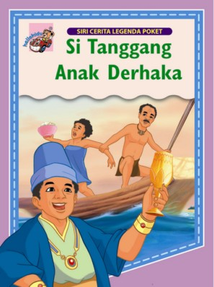
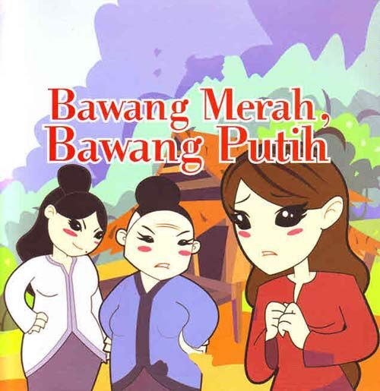

Si Tanggang Anak Derhaka
By Nasir Wahab
•Paperback
•Non-glossy pages
•Suitable for children 10 years old and above
•Colourful illustrations
•Illustrated by Park Hyung Sik
•100 pages
•RM 30.00

Bawang Putih Bawang Merah
By Ain Maisara
• Hardback
•Glossy page
•Suitable for children 7 years old and above
•Published by Star A Publication
•Colourful illustrations
•Illustrated by Marlia Musa
•120 pages
•RM 20.00

Your aunt wants to buy a book for you. She asks you to choose which book that you like. Write a message to her to tell her at least three reasons for your choice. Write your answer between 50 to 80 words.
Makcik kamu ingin belikan buku untuk kamu.Beliau meminta kamu memilih buku yang kamu suka. Tulis mesej bersama tiga sebab mengapa kamu memilih buku itu. Tulis jawapan kamu di antara 50 hingga 80 perkataan.

Dear _____________________________________
_________________________________________________________________________________________________________________________________________________________________________________________________________________________________________________________________________________________________________________________________________________________________________________________________________________________________________________________________________________________________________________________________________________________________________________________________________________________________________________________________________________________________________________________________________________________________________________________________________________________________________________________________________________________________________________________________________________
From,
_______________________

12 marks

SECTION C
( 25 marks )
This section consists of two questions. Answer ONE question only.

Question 1
Write a story based on the given pictures. You may use the questions and words given to help you. Write your answer in the space provided. Your story should be between 80 and 100 words.

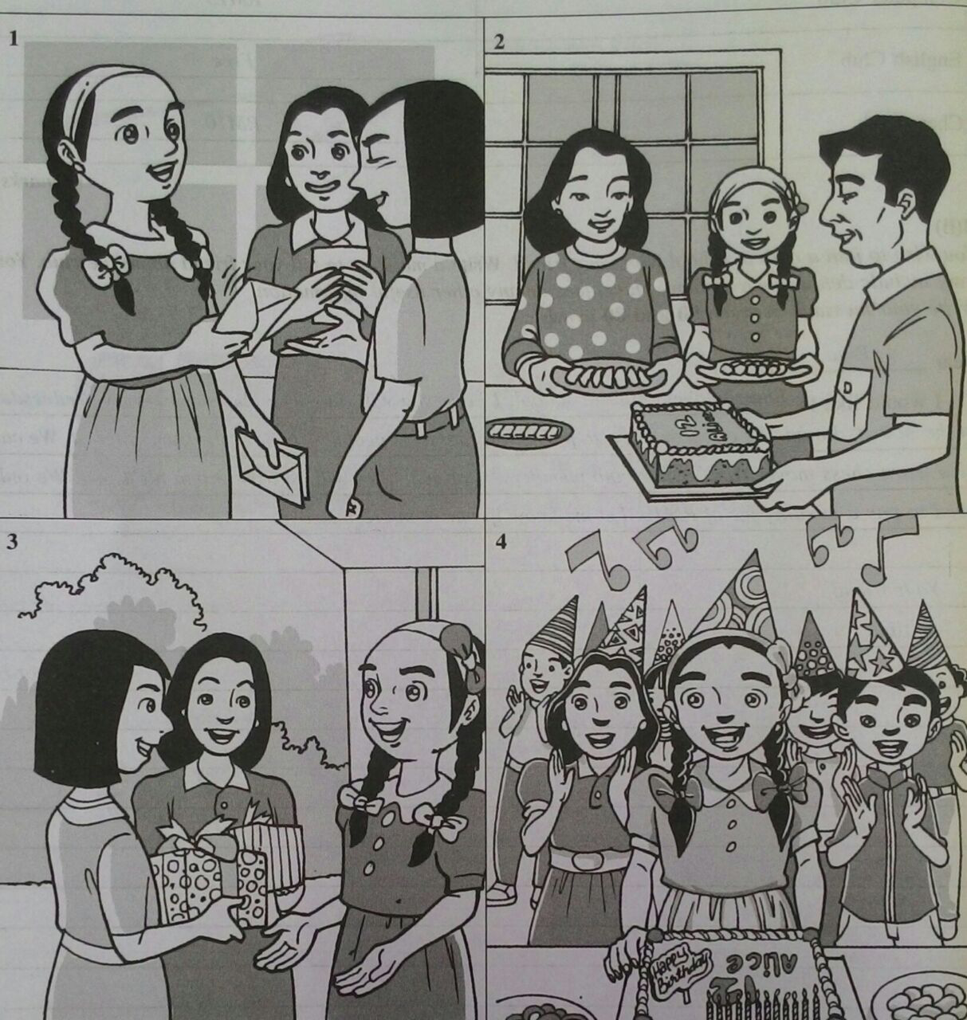
- Alia
- celebrated
- birthday
- invited
- friends
- party
- mother
-prepared
- food
- brought
- presents
-father
- bought
- cake
- eleven candles
- sang
- birthday song
- ate
- play games

.

- When did Alia celebrate her birthday?
- Who did she invite to her birthday party?
- What did her friends give to Alia on her birthday?
- What did Alia’s father buy on her birthday?
- Who prepared food and drinks for the party?
- How many candles were there on Alia’s cake?
- Was Alia happy?
- Did Alia thank her parents for organizing her birthday party?

OR
Question 2
Write a story based on the pictures below. You may use the words given to help you. Write your story in the space provided. Your story should be between 80 and 100 words.

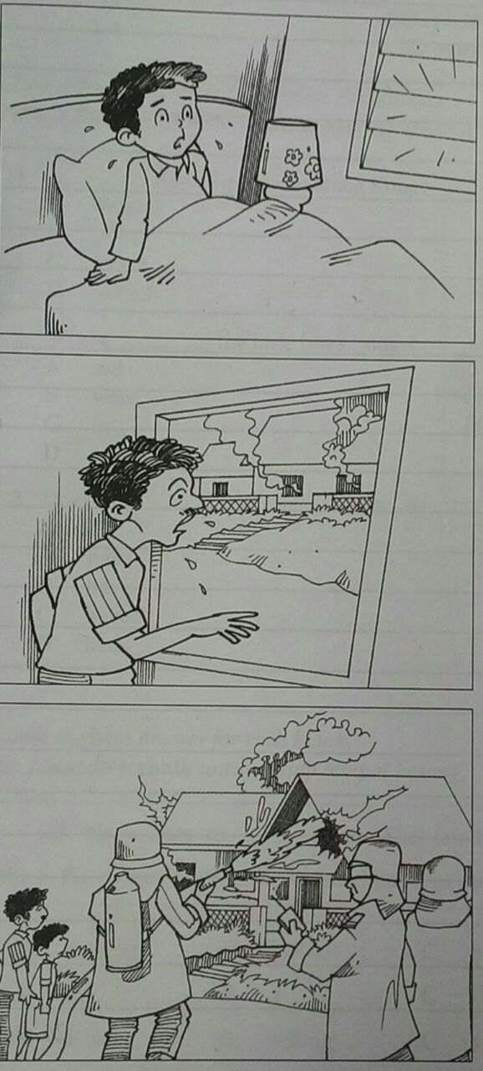

Ravi – parents – fast asleep – heard - screaming

fire engine – arrived - three – firemen – hose – managed – put out
father - woke up – saw – fire – phoned – fire brigade

Question number _________________

________________________________________________________________________________________________________________________________________________________________________________________________________________________________________________________________________________________________________________________________________________________________________________________________________________________________________________________________________________________________________________________________________________________________________________________________________________________________________________________________________________________________________________________________________________________________________________________________________________________________________________________________________________________________________________________________________________________________________________________________________________________________________________________________________________________________________________________________________________________________________________________________________________________________________________________________________________________________________________________________________________________________________________________________________________________________________________________________________________________________________________________________________________________________________________________________________________________________________________________________________________________________________________________________________________________________________________________________________________________________________________________________________ 25 marks

