Name : ________________________________________
Class : 1 ( Arif / Bijak / Cerdik / Didik / Evolusi )

PERPERIKSAAN PERTENGAHAN TAHUN 2017
SEKOLAH KEBANGSAAN PANDAN KUANTAN
BAHASA INGGERIS
TAHUN 1

SECTION A
(20 marks)

Circle the CORRECT answer.
1. | 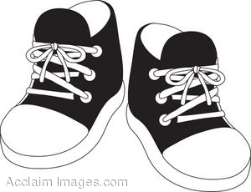 | Ali is wearing a __________.  - Shoe  - Book  - Ruler
2. |  | I have __________ pencils.  - Seven  - Ten  - Six
3. |  | Turn off the _________.  - Tap  - Ruler  - Water
4. | 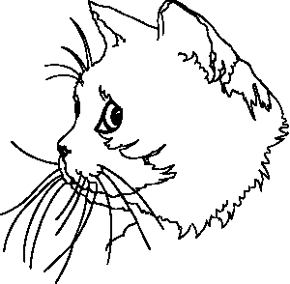 | This is my pet. It is a __________.  - Cat  - Dog  - Snake
5. | 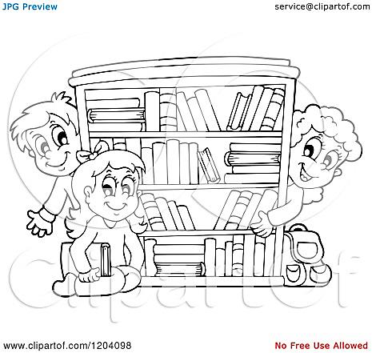 | I like to go to ____________.  - Field  - Toilet  - Library

Choose the CORRECT answer for each blank.
This is Maria. She is a (6) __________. She is seven years old. Her (7) ________ is a doctor. Her (8) _________is a nurse. Her brother likes to play the (9) __________. Her sister likes to wear (!0) ___________.

6. A Girl
B Boy
C Man

7. A Brother
B Sister
C Father

8. A Brother
B Mother
C Father

9. A Drum
B Muffin
C Mat

10. A Ducks
B Dress
C Milk

Choose the sentence with the correct PUNCTUATION.

11. A what are those flower
B What are those flower?
C What are those flower.

12. A those are daisies.
B Those are daisies?
C Those are daisies.

Based on the picture, choose the BEST answer.
How to cross a road?
13. Stop at the _________.
A Roadside
B Road
C Seaside

14. Look _______, left and right again.
A Right
B Up
C Left
15. _________ carefully of the sounds of incoming cars.
A Look
B Don’t
C Listen

16 When there are no cars, use the ___________ to cross the road.
A Zebra crossing
B Lollipop man
C Cars

Look at the picture and circle the correct answers.
17 . The boys are playing football at in the ___________
- Field
- Toilet
- Classroom

18. Ani borrows books from the ___________
A. office
B. library
C. canteen

19. The pupils are eating in the
A. classroom
B. bookshop
C. canteen

20. The pupils have their lessons in the ______________
A. library
B. canteen
C. field

SECTION B
[30 Marks]
Question 21
Write a suitable respose for each picture,
Hello , I am Maream.
Good afternoon.
Thank you.
I’m sorry, mother.
Goodbye.

a)
Hello, I am Encik Nasrul.

Answer :
_______________________________________________
_______________________________________________
b)
Goodbye.

Answer :
________________________________________________
________________________________________________
c)
Here is some muffins for you.

Answer :
________________________________________________
________________________________________________
d)
I’m sorry mother.

Answer :
________________________________________________
________________________________________________
e)

Answer :
___________________________________________________
___________________________________________________
( 10 marks )
Question 22
Read and answer the questions.
These are my teeth. I have clean and white teeth. I brush my teeth everyday. I brush my teeth with a toothbrush. I eat more vegetables and fish.They make my teeth strong. I avoid eating sweets to have strong teeth. I go to dentist every six months to check my teeth.

- What colour is my teeth?
It is ____________ .

- Why is my teeth strong?
I eat more __________ _______ ___________ .

- Where do I go to check my teeth?
I go to ___________ .

- I brush my teeth with a _________________ .

- I avoid eating _____________ to have a strong teeth.

( 10 marks )
Question 24
Match the sentences correctly.
Today is Monday. It is the first day of school. Ali is very happy. He is seven years old. Ali goes to school in the morning. At the afternoon, Ali has his lunch. At the evening, Ali plays football. Ali sleeps peacefully at night.
Time |  | Ali’s activities
Morning |  | He plays football.
Afternoon |  | He goes to school.
Evening |  | He has lunch.

( 6 marks )
Question 25
Tick ( ) to the correct answers.
- Ali is _____________ years old.
Seven
Eleven

- Ali is very _____________ .
Sad
Happy
( 2 marks )
- Good Luck –

Prepared by,

_________________

Verified by,

_________________

