SULIT | 013
Section A

(20 Marks)

- The Supermarket is located ____________ the Town Hall and the Police Station.

  - on

  - beside

  - across

  - between

- John asked if Mrs. Lim could give _____________ a lift to the bookstore.

  - he

  - her

  - him

  - his

- It is such a sunny day that Alif puts on a pair of ___________ to protect his eyes.

  - shoes

  - shorts

  - spectacles

  - sunglasses

- Nadya hurt her ____________ and could not walk.

  - wrist

  - ankle

  - elbow

  - shoulder

- The cowboy ___________ the horse and leaves the ranch immediately.

  - ride

  - rider

  - rides

  - riding

Choose the most suitable proverb.

Pilih peribahasa yang paling sesuai.

- “Kenneth, you are a week behind schedule on your science project. You better start working on it. Remember, ___________,”said Edith.
  - look before you leap

  - better late than never

  - a burnt child dreads the fire

  - make hay while the sun shines

2

SULIT | 013

Question 7-9

Choose the best answer for each blank.

Pilih jawapan yang terbaik untuk setiap tempat kosong.

Cinderella rushed _____(7)_____ the garden and knelt by a stone bench, sobbing her heart out. It was so _____(8)_____! She had always had faith in her dreams. It had been her dearest wish to go to the ball, to wear a pretty dress, _____(9)_____ to dance like other young girls.

- A. in

  - into

  - over

  - inside

- A. unfair

  - unsure

  - unhappy

  - unfaithful

- A. or

  - so

  - but

  - and

Question 10

Choose the word that has similar meaning as the underlined word.

Pilih perkataan yang sama erti dengan perkataan bergaris.

The sailors were afraid of sea monsters and band of pirates.

- tired

- thankful

- thinking

- terrified

Question 11

Choose the sentence with the correct punctuation.

Pilih ayat yang mempunyai tanda baca yang betul.

A. “Can you help me, with the laundry please?”asked Abby.

B. “Can you help me with the laundry, please?”asked Abby.

C. “Can you help me, with the laundry, please?”asked abby.

D. “Can you help me, with the laundry, please?”asked Abby.

3

SULIT | 013

Questions 12-15

Look at the picture and choose the best answer.

Lihat gambar dan pilih jawapan yang terbaik.
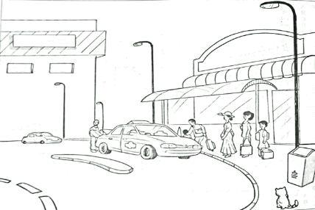

Last Sunday, Mary went to town with her mother. Afterwards, they decided to take a ___(12)__ home because they had done a lot of shopping. There was a queue at the taxi stand. Mary and her mother stood behind a ___(13)___ lady. She wore a long ___(14)___. A man and a boy were ___(15)___

into a taxi. Mary and her mother had to wait for half an hour before they got a taxi home.

- A. bus

    - taxi

    - train D. trishaw

- A. tall

  - cute

  - short

  - plump

- A. skirt

  - dress

  - blouse

  - trousers

- A. falling

  - sitting

  - getting

4

SULIT | 013
- walking

Question 16-20

Read the story below carefully and answer the questions that follow.

Baca cerita di bawah dan jawab soalan-soalan yang berikutnya.

A shoemaker and his wife lived in a little house on the edge of the woods. They were very poor, and each day they grew poorer and poorer.

At last there was nothing left in the house but leather for one pair of shoe. “Iwill cut out this last pair of shoes,”the shoemaker said to his wife. “Tomorrow I will sew them and peg them.”So he cut out the leather and left it on his bench.

The next morning he went into his shop to make the shoes. What did he see? A pair of shoes all nicely made and ready to be sold. The stitches were so neat, and the shoes so well made that they were quickly sold.

With the money, the poor shoemaker bought leather for two pair of shoes. Then he said to his wife, “Iwill cut out the leather for two pairs of shoes. Tomorrow I will sew them and peg them”.So he cut out the leather for the shoes and left it on his bench.

The next morning when he went into his shop to make the shoes, what did he find? Yes, there were two pairs of shoes already made. The work was so well done that those shoes were also sold very quickly.

With the money, the poor shoemaker bought enough leather for four pairs of shoes. Those he also cut out and left upon his bench but this time he decided to stay overnight and watched who had been helping him all along.

He waited patiently. Suddenly, in the middle of the night, he saw four little elves, each no bigger than his thumb came in through a hole on the wall of his old shop. The elves started making the shoes and they were fast. Before dawn, there were four pairs of beautiful shoes, all well made.

Slowly, the shoemaker came out of his hiding and friendly greeted the elves. The elves were surprised at first but felt at ease when the shoemaker offered them biscuits and hot chocolate drinks.

While sitting and having the meal, the shoemaker took the chance to say thank you. He also asked to be taught in making better quality shoes the way the elves did them. The elves agreed and promised to come back at tomorrow night.

And so it went on and on. Instead of being a very poor shoemaker, he became a very rich person. His shoes were so well made that even the queen herself wore them.

5

SULIT | 013
- Who helps the shoemaker make the nice shoes?

        - His wife

        - The Elves

        - The Queen

        - His Children

  - What does the shoemaker buy with the money he makes selling shoes?

        - Shoe

        - Bench

        - Bread

        - Leather

    - Which of the statement is NOT TRUE?

        - All the shoes were hand-made of leather.

        - The shoemaker lived in a little house near the forest.

        - Without the help, the shoemaker might lose his shop to the queen.

        - The new shoes had better quality than the ones made by the shoemaker.

      - Why the queen wears the shoemaker’sshoes?

        - The shoemaker is very rich

        - The shoes are expensive.

        - The shoes are well made.

        - The shoes are magical

      - When the shoemaker asked the elves to teach him to make better shoes, it means that he is willing to

        - prepare more biscuits and drink

        - improve his ability in making shoes

        - gain royal attention from the queen

        - steal the skill and get rid of the elves

6

SULIT | 013
Section B

(30 Marks)

Question 21

Based on the given pictures, give the correct answers in full sentences.

Write your answers in the spaces provided.

Berdasarkan gambar-gambar, berikan jawapan dalam ayat yang penuh.

Tulis jawapan di tempat yang disediakan.

(a) |  |  | Answer:
 |  | _____________________________________
 |  | _____________________________________
 |  | _____________________________________
 |  | _____________________________________
 |  |  | (2 marks)
(b) |  |  | Answer:
 |  |  | _____________________________________
 |  |  | _____________________________________
 |  |  | _____________________________________
 |  |  | _____________________________________
 |  |  | (2 marks)
(c) |  |  | Answer:
 |  |  | _____________________________________
 |  |  | _____________________________________
 |  |  | _____________________________________
 |  |  | _____________________________________
 |  |  | (2 marks)
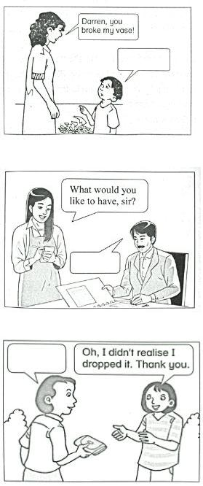

7

SULIT |  |  |  |  |  |  |  |  |  |  |  |  |  | 013
Study the flyer below. Answer the questions that follow.
Teliti risalah di bawah. Jawab soalan-soalan berikutnya.
 |  |  |  |  | Children s Section |  |  |  |  |  |  |  |  |  |  | FURNISHING SECTION
 |  |  |  |  | ’ |  |  |  |  |  | PUTRA MEGA MALL
 |  |  |  |  | 70% off |  |  |  |  |  |  |  |  |  |  | 30% OFF
 |  |  |  |  | Shoes * Clothing |  |  |  |  |  | KOTA KINABALU
 |  |  |  |  |  |  |  |  |  |  | 14 –20 March 2016
 |  |  |  |  |  |  |  |  |  |  |  |  |  | LADIES’SECTION
 |  |  |  |  |  | 50% -80% off |  |  |  |  |  |  |  | 50% Discount
 |  |  |  |  |  | GENTS’SECTION |  |  |  |  |  |  |  |  | Clothing
 |  |  |  |  |  |  | Shirts * Shoes
 |  |  |  |  |  |  |  |  |  |  |  |  |  | Handbags
 |  |  |  |  |  |  | *Belts* Pants
 |  |  |  |  |  |  | *Ties * Coats |  |  |  |  |  |  | Cosmetics
 |  |  |  |  |  |  |  |  |  |  |  |  |  | Perfumes
 |  |  |  |  |  |  |  |  |  |  |  |  |  |  | Shoes
 |  |  |  |  |  |  | h
 |  |  |  |  |  | t
 | 5 |  |  |  |  |  |  |  |  |  | There will be a Colouring Competition
 |  |  |  |  |  |  |  |  |  | on 19th March 2016 for youth aged 17 years old and below.
Question 22 –23
Tick (√) the right answer.
Tanda (√) pada jawapan yang betul.
22. (a) The flyer is about a…
 |  |  |  | Sale
 |  |  |  | lucky draw
 |  |  |  | colouring competition |  |  |  |  |  |  |  |  |  |  |  |  | (1 marks)
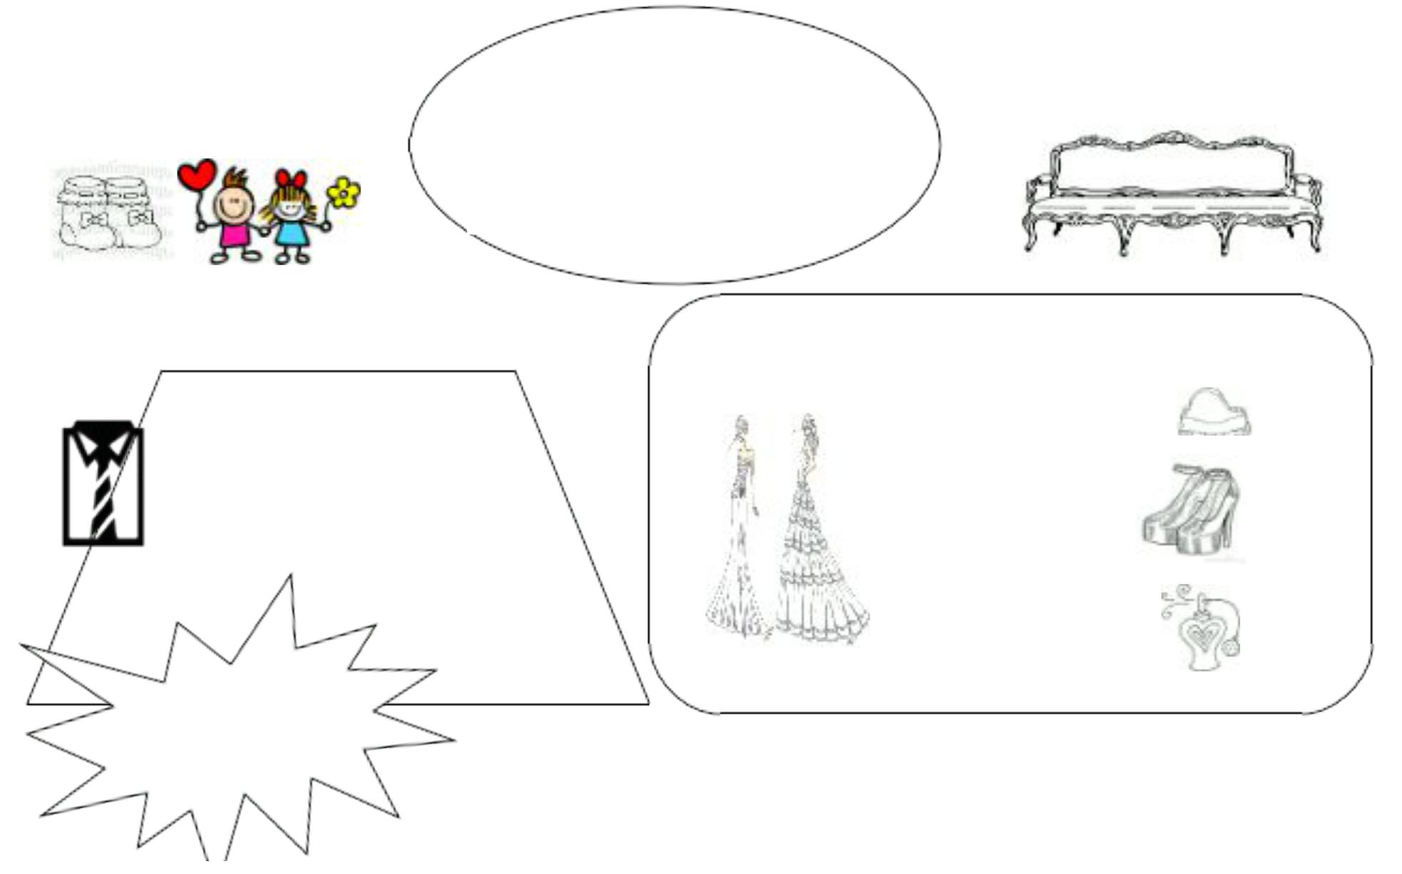

(b) Which item cannot be found in the Furnishing Section?

Curtains

Sport Shoes

Cushion Covers _{(1 marks)}

8

SULIT | 013

23. (a) State TRUE or FALSE for each sentence below.

(i) Putra Mega Mall has been operating for 5 years ______________

(ii) The Furnishing Section is giving a discount of 30% ______________

(iii) There will be a colouring competition on the first day of the sale ______________

(iv) Putra Mega Mall is having a year-end sale ______________

(4 marks)

- Sofia is at the Ladies’Section . She wants to buy a dress priced at RM100. How much would she pay?

________________________________________________________________________________

(2 marks)

- Why do you think Putra Mega Mall is organising a colouring competition during the sale?

________________________________________________________________________________

(2 marks)

9

SULIT | 013

Read the passage below and answer the following questions that follow.

Baca Petikan di bawah dan jawab soalan-soalan berikut.

Raisins are dried grapes that have been eaten for thousands of years. Nearly 3,500 years ago, the first raisins were discovered as grapes that were drying in the sun on a vine. In medieval Europe, raisins were used as sweeteners, medicine, and even as a form of money!

In America, raisins were first grown after an 1873 heat wave in California destroyed its valuable grape crop, leaving only dried, wrinkly, but tasty grapes on the vines. Soon, farmers began developing seedless grapes in California that were thin-skinned and sweet. These grapes would be purposely dried in the sun and became the popular dark raisin we eat and enjoy today. Later, a golden variety of raisin was made by treating grapes with a chemical called sulphur dioxide and using special methods to dry them.

Today, central California remains the centre of the world’sraisin industry, producing nearly 95 percent of the world’s raisins. Its green valleys, sunny climate, and hot temperatures provide the perfect conditions for grapes that are dried into raisins.

Question 22

Tick (√) the right answer.

Tanda (√) pada jawapan yang betul.

(a) Which of the following were raisins NOT used as

sweetener

medicine

weapon

(b) Raisins…

were discovered recently

were discovered a long time ago

are made by dropping grapes in water

(1 marks)

(1 marks)

10

SULIT | 013

Write your answers in the spaces provided.

Tuliskan jawapan pada ruangan yang disediakan.

(c) How were the first raisins discovered?

________________________________________________________________________________

________________________________________________________________________________

(2 marks)

(d) What happened in 1873?

________________________________________________________________________________

________________________________________________________________________________

(2 marks)

(e) Do you think we can produce raisins in Sabah? Give a reason for your answer.

________________________________________________________________________________

________________________________________________________________________________

(2 marks)

11

SULIT

Read the television guide below and answer the questions that follow.

Baca intisari rancangan di bawah dan jawab soalan-soalan yang berikutnya.


TV GUIDE –CHANNEL SUTRA RIA

7.00 | a.m. Good Morning Malaysia | 3.30 p.m. Challenge Your Mind
9.00 | a.m. The Big Breakfast Show | 4.30 p.m. Spongebob Squarepants
9.30 | a.m. Body Work | 5.30 p.m. Local News
10.00 a.m. Upin Ipin |  | 6.00 p.m. Wildlife Planet
11.00 a.m. Chef Wan’sCooking Tour |  | 7.00 p.m. World of History
12.00 p.m. News at Noon |  | 7.30 p.m. Funniest Home Video
12.30 p.m. The Rich and Famous |  | 8.00 p.m. World News
1.30 p.m. Winter Melody Episode 17 |  | 9.00 p.m. The Box Office –
2.30 p.m. Bollywood Hitz |  | ‘Tomorrowland’
 |  | 11.00 p.m. Negaraku

Question 23

Tick (√) the right answer.

Tanda (√) pada jawapan yang betul.

(a) How frequent is news aired on Channel Sutra Ria?

Once

Twice

Thrice

(b) Which of the following programs is most probably a Korean drama? Chef Wan’sCooking Tour

013

(1 marks)

12

SULIT |  |  |  | 013
 |  | Winter Melody |  | (1 marks)
 |  | World of History |  | (1 marks)

(c) If you are concerned with a healthy lifestyle, which program you would not miss?

________________________________________________________________________________

(2 marks)

(d) Ryan loves watching Chef Wan’sCooking Tour. What do you think is his interest?

________________________________________________________________________________

(2 marks)

13

