SULIT

BAHASA INGGERIS
Kertas 2 - Penulisan
Tahun 1
Mei
2017
1$\frac{1}{4}$ jam

PEPERIKSAAN PERTENGAHAN TAHUN 2017
TAHUN 1

Nama : …………………………………………………………………………. Kelas : ………………………………………………..

BAHASA INGGERIS
Kertas 2 - Penulisan

Satu Jam lima belas minit

JANGAN BUKA KERTAS SOALAN SEHINGGA DIBERITAHU

- Kertas soalan ini mengandungi tiga bahagian : Bahagian A, Bahagian B dan Bahagian C.
- Kamu dikehendaki menjawab ketiga-tiga bahagian.
- Bagi Bahagian C, kamu boleh memilih sama ada menjawab Soalan 1 atau Soalan 2.
- Jawapan kamu hendaklah ditulis pada ruang yang disediakan dalam kertas soalan ini.

Kertas soalan ini mengandungi 6 halaman bercetak

SECTION A
[10 marks]

Study the notes below and use the information to complete the following text.

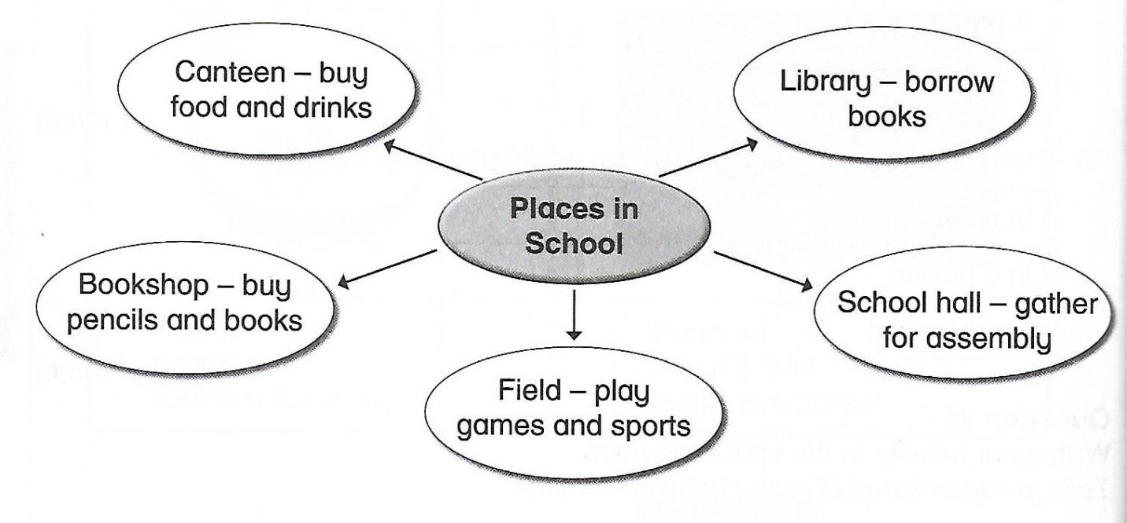

Every morning, the pupils gather at the _____________________________________(1) for assembly. Then they go to their classroom to learn. During recess, they go to the canteen. They _____________________________________________(2) here. Some like to go to the library to _____________________________________________(3). Others will play games at the _____________________________________________(4). If they want to buy _____________________________________________(5), they will go to the bookshop.

[10 marks]

SECTION B
[15 marks]

Study the pictures and the information given.

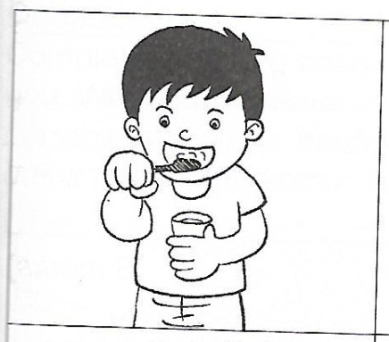
Teeth
- brush your teeth twice a day
- tooth paste and toothbrush

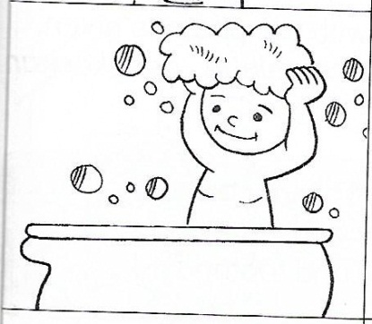
Hair
- wash your hair at least three times a week
- shampoo

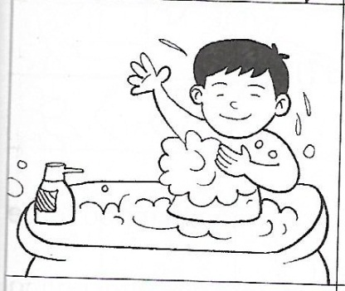
Body
- take a bath twice a day
- soap

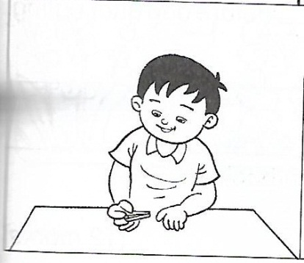
Fingernails
- cut your fingernails once a week
- a nail clipper

B(i) Fill in the blanks with correct answers. One has been done for you.
Item | Activity
Toothbrush | Brush my teeth
Shampoo
Soap
Nail clipper

[3 marks]

B(ii) Write what you do to keep clean. Complete the text with the phrases given.

wash my hair using a nail clipper

brush my teeth using soap and water

wash my hands toothbrush and toothpaste

I wake up in the morning and brush my teeth. I use a _____________________________________(1). Then I bathe ______________________________________________(2). I will __________________________________________(3) with shampoo three times a week. I always _________________________________________(4) before and after eating. Once a week, I will cut my fingernails _____________________________________(5). I do not bite my fingernails. I will ____________________________________________(6) again before going to sleep every night.
[12 marks]

SECTION C
[25 marks]

This section consists of two questions. Answer one question only.

Question 1
Complete the story based on the picture below. Choose the phrases given to help you. Write your answer in the space provided.

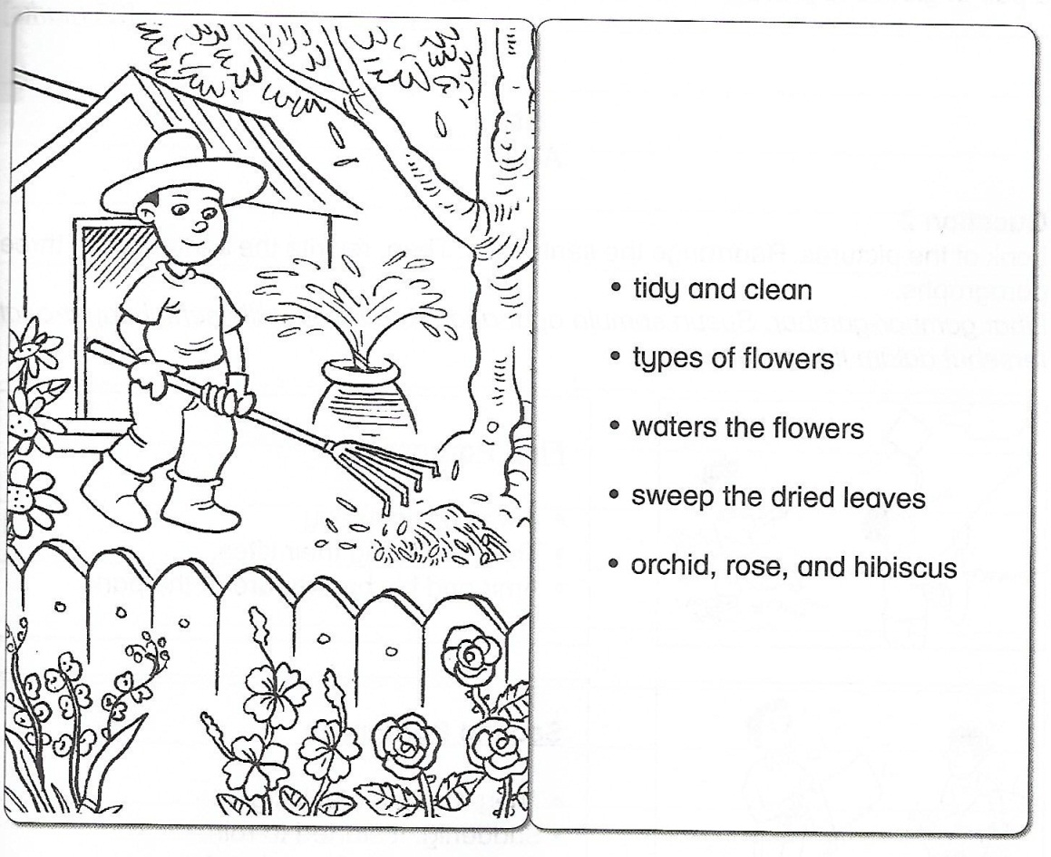

Encik Amar’s hobby is gardening. He has planted many _______________________________(1) in his garden. There are sunflower,___________________________________(2) plants. He ______________________________________(3) every morning. He keeps his garden ______________________________________(4). He will ____________________________________(5) with a rake. He wears a pair of gloves to protect his hands. He is very proud of his garden.
[25 marks]

OR

Question 2
Look at the pictures. Rearrange the sentences. Then, rewrite the sentences in three paragraphs.

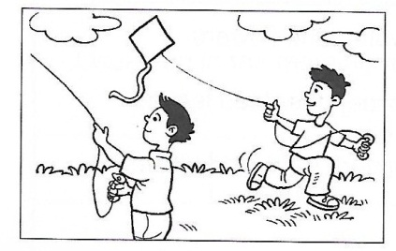
First Paragraph
- It was a windy day
- They are flying their kites
- Amir and his brother are at the park

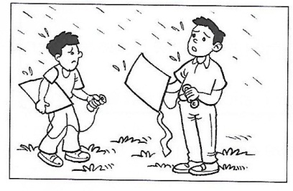
Second Paragraph
- They ran home quickly
- Suddenly, it started to rain
- The boys took down their kites

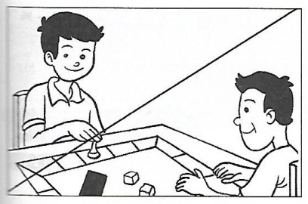
Third Paragraph
- They stayed in their house
- They decided to play a board game
- Once they arrived home, it was raining heavily

___________________________________________________________________________________________________________________________________________________________________________________________________________________________________________________________________________________________________________________________________________________________________________________________________________________________________________________________________________________________________________________________________________________________________________________________________________________
[25 marks]
End of question
Answer Scheme

Section A
- school hall
- buy food and drinks
- borrow books
- school field
- pencils and books

Section B

B(i)
shampoo - wash my hair
soap - wash my body
nail clipper - cut my fingernails

B(ii)
- toothbrush and toothpaste
- using soap and water
- wash my hair
- wash my hands
- using a nail clipper
- brush my teeth

Section C

Question 1
- types of flowers
- orchid, rose and hibiscus
- waters the flowers
- tidy and clean
- sweep the dried leaves

Question 2

It was a windy day. Amir and his brother are at the park. They are flying their kites. Suddenly, it started to rain. The boys took down their kites. They ran home quickly.

Once they arrived home, it was raining heavily. They stayed in their house. They decided to play a board game.

