A. Read and complete
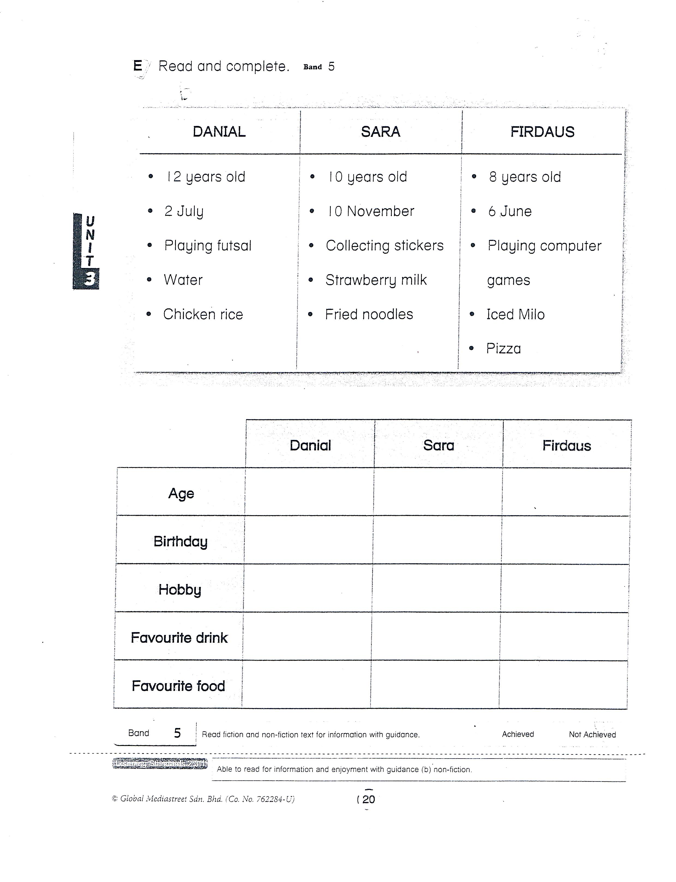
Strawberry milk
Playing futsal
Pizza
2 July
10 years old
10 marks

B. Write
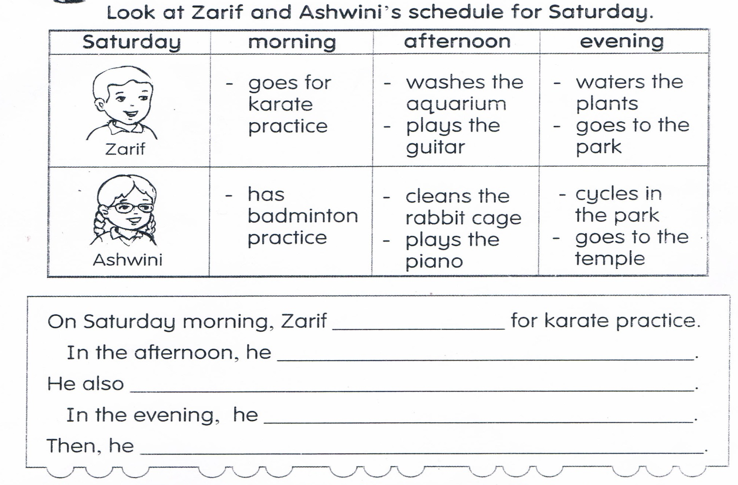
05 marks

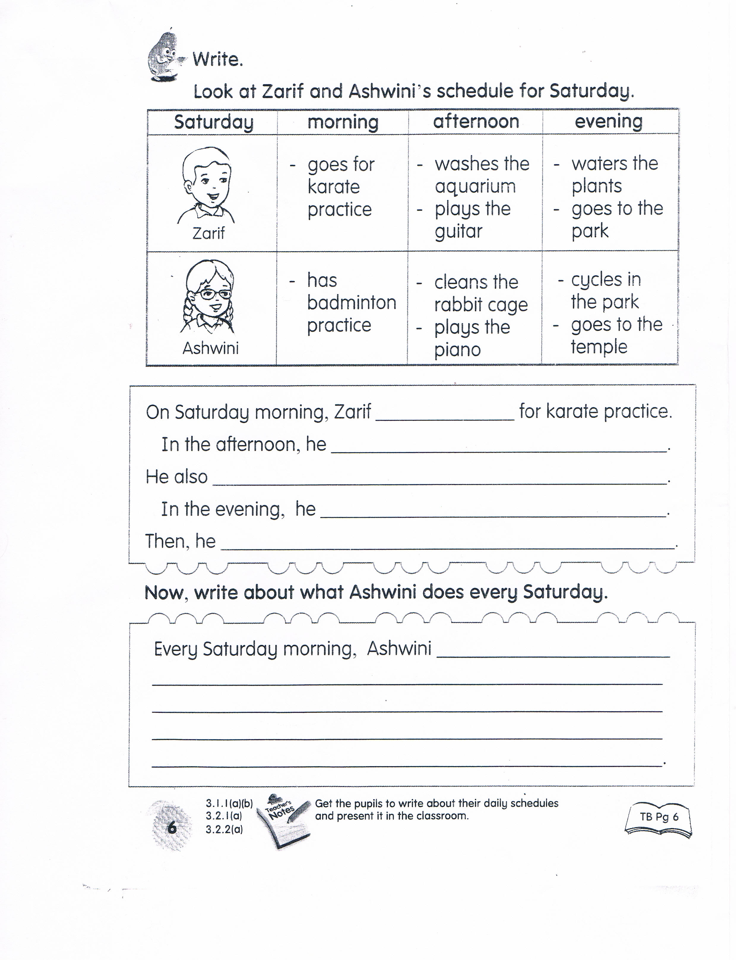
10 marks

C. Look at the pictures below. Rearrange the words to form correct sentences.
10 marks
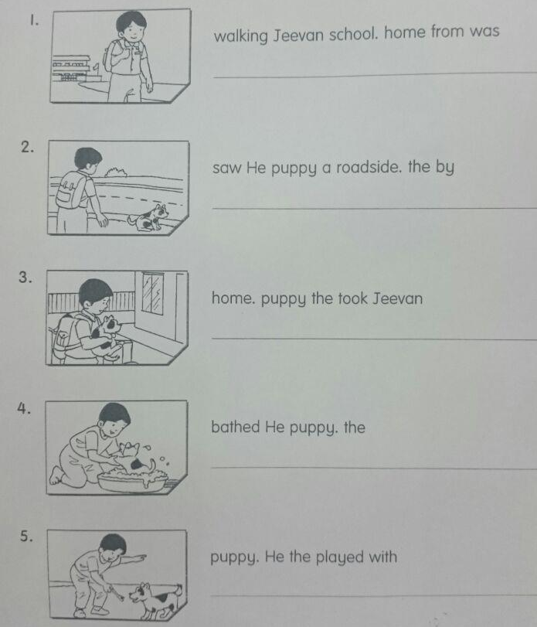
home. puppy the took Jeevan
saw He puppy a roadside. the by
walking Jeevan school. home from was
D. Match the sentence parts. 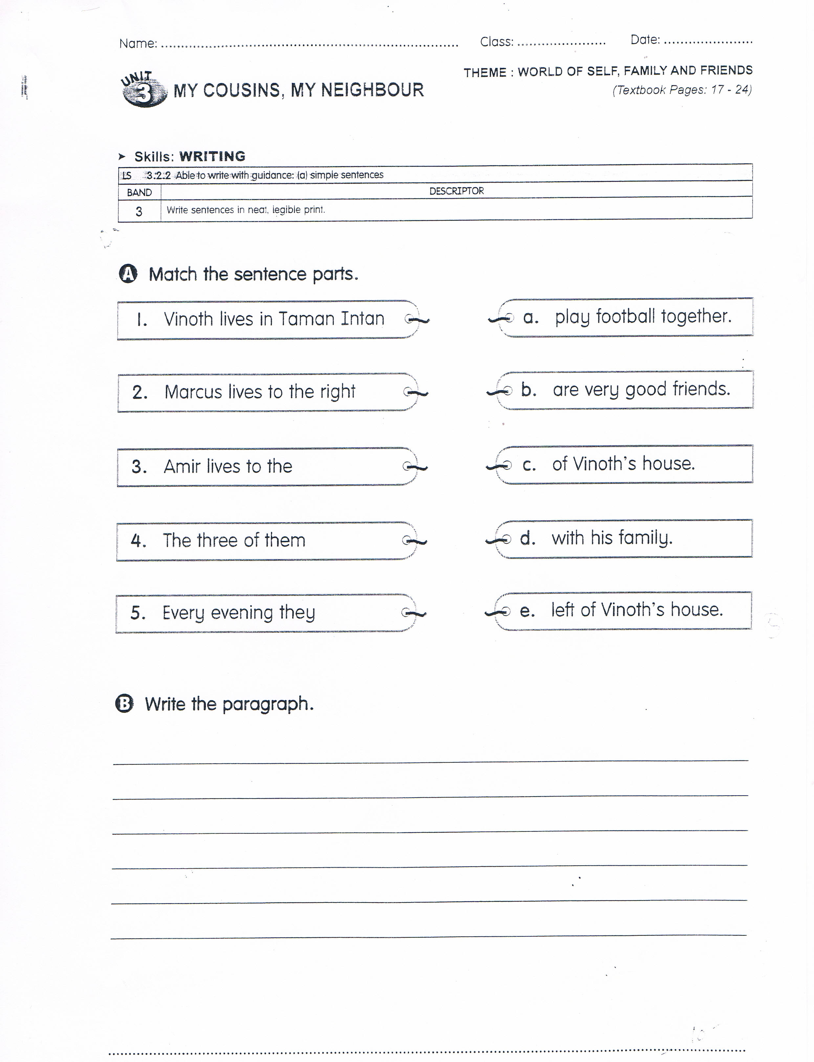
10 marks
05 marks
E. Write the paragraph.

