SECTION A

Questions 1 -4
Choose the best answer to complete the sentence.
Pilih jawapan yang yang terbaik untuk melengkapkan ayat berikut.

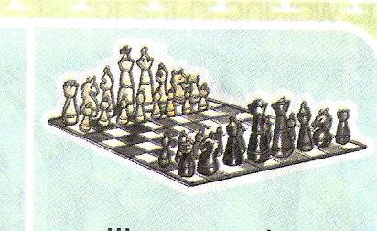
- He likes ______________ during his free time.
A playing badminton
B playing football
C playing chess
- Ahmad sleeps in the ______________.
A bedroom
B bathroom
C living room
- A _____________ sails across the sea.
A ship
B bus
C bicycle
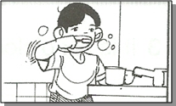
4 Karim always ________________ after he wakes up
In the morning
A brushes his teeth
B take his bath
C changes his clothes

- Pulau Langkawi is a small ________________.
A world
B town
C island

Choose the most suitable proverb.
Pilih jawapan yang sesuai

- Zaidi loves playing football like his father, En. Mahmud. As the saying goes, ___________________

A better late than never
B like father like son
C practice makes perfect

Choose the best answer to complete the paragraph.
Pilih jawapan yang terbaik untuk lengkapkan perenggan di bawah.
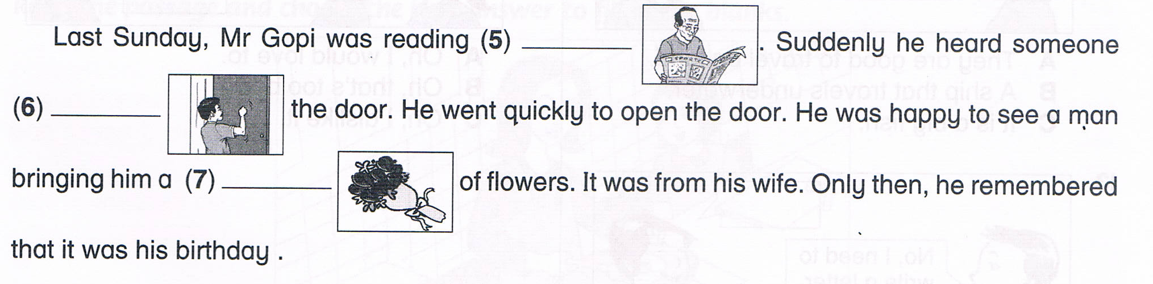

- A a newspaper
B a book
C a magazine

8 A pushing
B hitting
C knocking

9 A bouquet
B jar
C group

Give the opposite meaning of the underlined word.
Berikan kata berlawanan bagi perkataan yang bergaris

10 He is very hardworking.

A slow
B handsome
C lazy

Choose the sentences with the correct punctuation.
Pilih ayat yang mempunyai tanda baca yang betul.

11 A Maria buys a pen a ruler and an eraser.
B Maria buys a pen, a ruler, and an eraser.
C Maria buys a pen. a ruler and an eraser

Look at the picture and choose the best answer
Lihat gambar dan pilih jawapan yang terbaik.

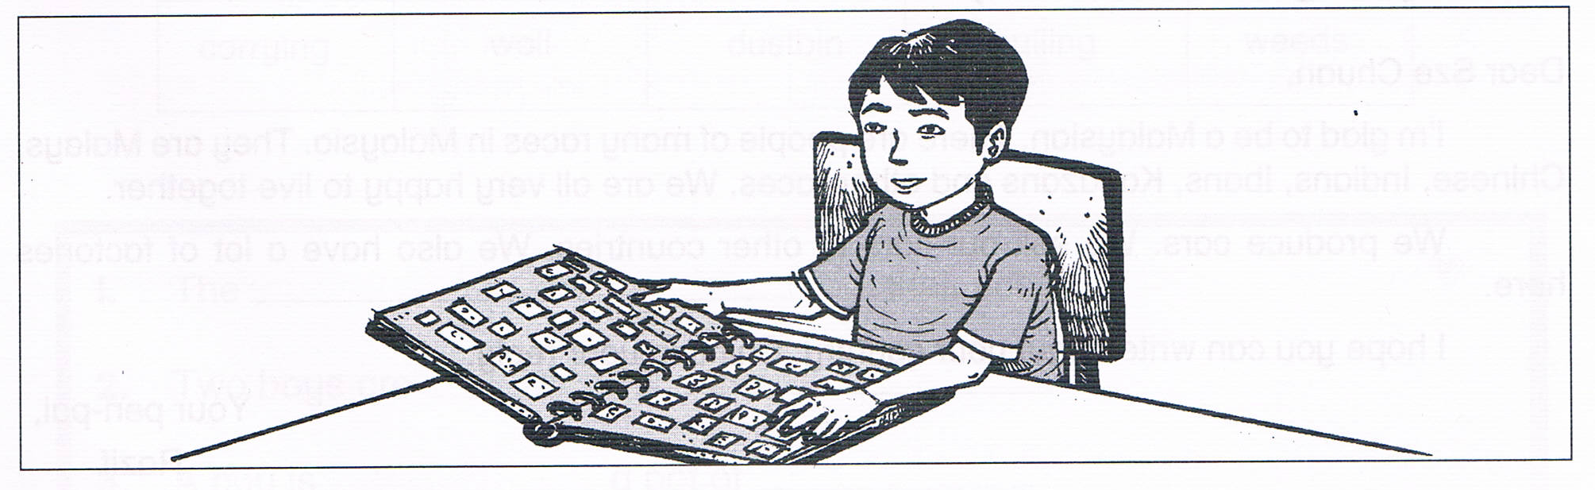

Collecting stamps (12) __________ a good hobby. We can (13)_________
the names of many countries. We can keep all the (14) _______ in an album.
We feel happy if we (15) ____________ a lot of stamps.

12 A is 13 A know
B are B knew
C was C knowing

14 A stem 15 A has
B stamps B have
C stamp C had

Read the poem below carefully. Answer the questions given.
Baca sajak di bawah. Jawab soalan yang diberikan.

I have a yellow blouse
I have a blue jeans
I love to wear them
When I go camping

Going to school
in a white uniform
with the white socks
and the white shoes too

Mother buys me
A dress to wear
It is so beautiful
That I like it the best

16 What is the colour of the blouse? 17 Who buy the dress ?
A Blue A Mother
B White B Brother
C Yellow C Sister
18 What did I wear for camping? 19 Why I like the dress?
A Blouse and socks A Because it is beautiful.
B Jeans and uniform B Because it is black.
C Blouse and jeans C Because it is dirty.
20 Where did I go in white uniform?
A To the library
B To the school
C To the market

SECTION B

Question 21 ( 10 marks )
Give the correct answers in the space provided.
Tulis jawapan di tempat yang disediakan.

I’m sorry.
Good morning, Ali.
Hi. I’m Idris.
Thank you.
Here you are.

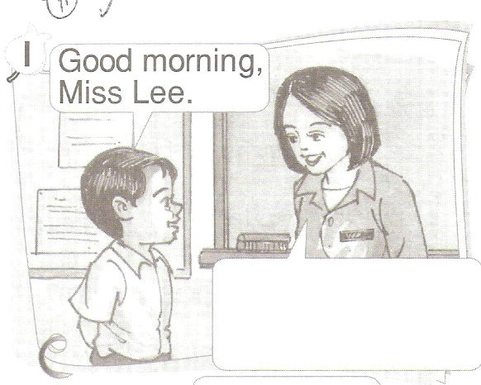
a
__________________________________
.

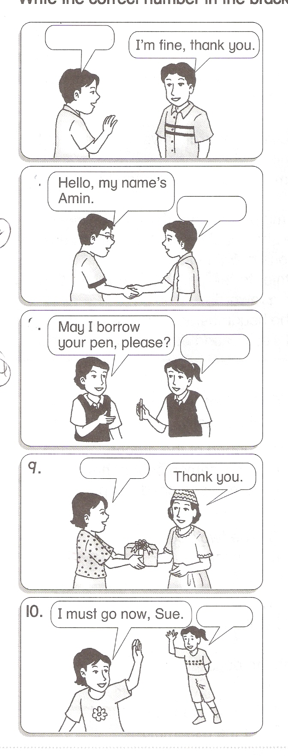
b
__________________________________
.

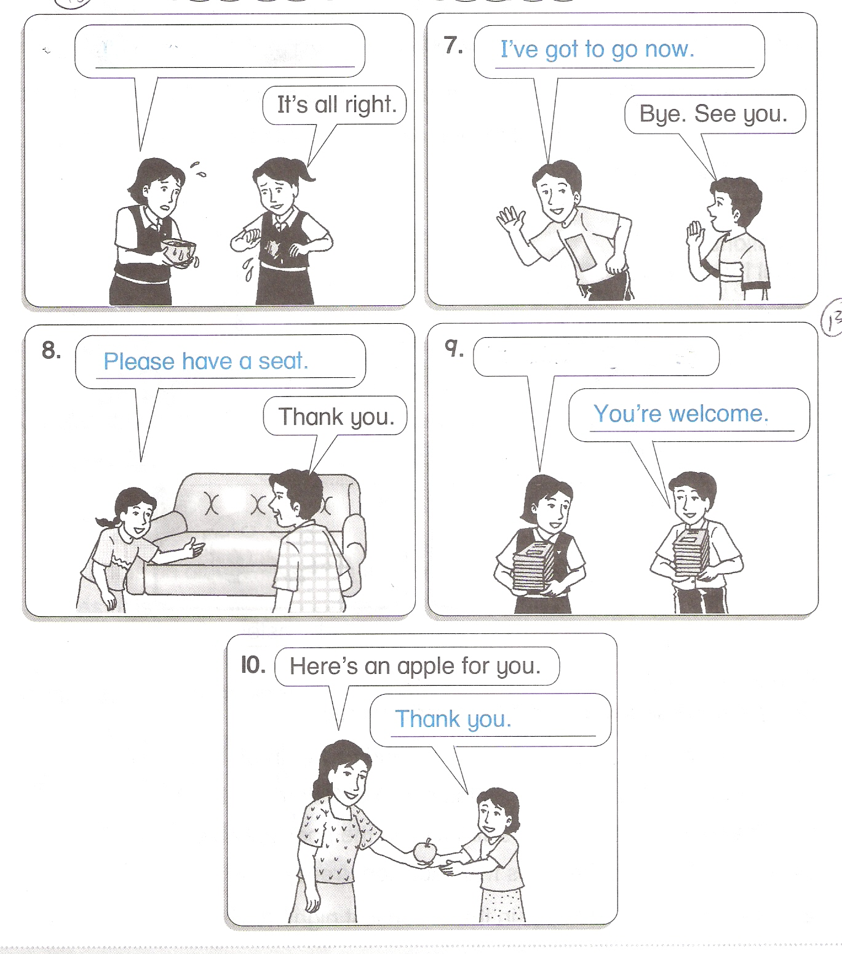
c
__________________________________

d

__________________________________

e
__________________________________

Question 22 ( 10 marks )
Read the information below. Answer the questions.
Baca maklumat di bawah. Jawab soalan yang diberikan.
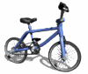
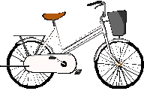
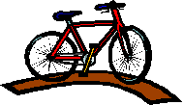

BIKE TRAINER JUNIOR BIKE MOUNT BIKE
❒ Blue  Red  Green
❒ Small  Medium  Big
❒ RM 100.00  RM 150.00  RM 200.00
❒ Light  Light  Heavy
❒ Basket  Two speed gear  Three speed
gear.

Tick ( / ) the correct answer
- Jamilah has RM120. She can afford to buy….
Bike Trainer
Junior Bike
Mount Bike

(2 marks)

- Mount bike has
Two speed gear
Three speed gear
Basket

(2 marks)

- Kenny is 20 years old. He should buy the __________________
because it is ______________.
(2 marks)

- Aminah likes the ___________________. She can put her books in
the ________________.
(2 marks)

- I would like to buy the ___________________. It is ______________.

(2 marks)

Question 23 ( 10 marks)
Read the passage and answer the questions.
Baca petikan di bawah. Jawab soalan yang diberikan

Erra and her family visited Taiping Zoo last holidays. Before entering the zoo, her father bought tickets at the entrance.

Erra’s brother, Ramlan was excited to see the animals. Erra and her family saw both the wild and the tame animals there. The wild animals were the tigers, lions, elephants and snakes. The tame ones were hens, roosters and a few types of cats. They snapped photographs with a Siamang monkey.

They were very happy to visit the zoo.

- When did Erra and her family visited the zoo?
They visited the zoo ________________________________________.
(2 marks)

- Anyone who enters the zoo needs to have a ___________________.
(2 marks)

- The opposite of wild is ____________________.
(2 marks)

- Why was Ramlan excited?
He was excited to see __________________________.
(2 marks)

- What did they do with the Siamang monkey?
They snapped _______________________.
(2 marks)

