- Write the small letters and capital letters correctly. ( 20 marks )
Example:
a
A

B
j

Q

d

K
m

Q
o

Y

s

H
t

E
i

G

n

R
u

f

L

- Name the pictures. ( 20 marks )
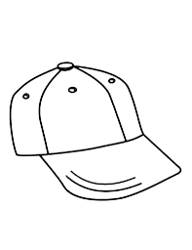
Example:

cap

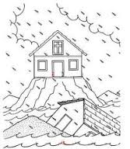
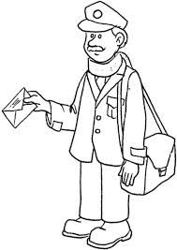
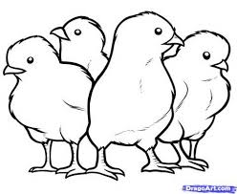

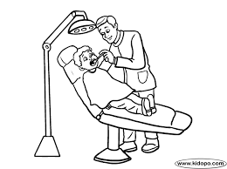
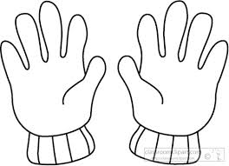
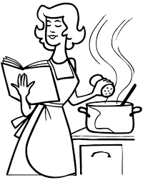

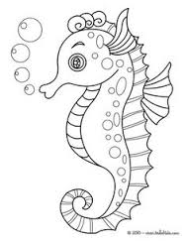
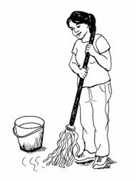
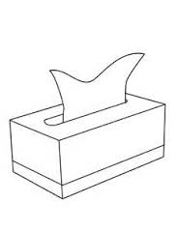

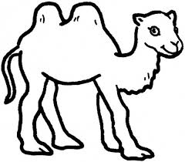
gloves | seahorse | postman
chicks | flood | camel
mopping | dentist | cooking
tissue paper | cap

- Rearrange the letters to form the correct words. ( 10 marks )
Example:
g i w s h n a
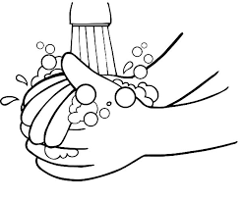
washing
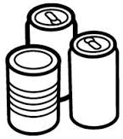
n c s a

______________________
2.
h e l w a
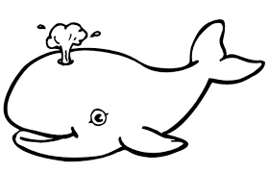

______________________
t o a c
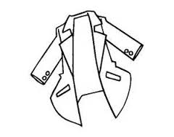
3.
______________________
r n k i d g n
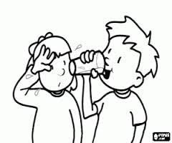
4.
_______________________
c f h e
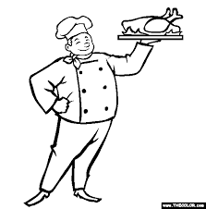
5.
_______________________

- Read and fill in the blanks with the correct answers. (10 marks )
I am fine
a plate of chicken rice
Thank you
restaurant
apple juice
menu

Waitress : Welcome to our restaurant. How are you?
Sara : _________________________________, thank you.
Can I have the ________________, please?
Waitress : Sure, here it is.
Sara : I would like to have ________________________________
and a glass of ___________________________.
Waitress : Your food and drink will be ready shortly.
Sara : _____________________________.
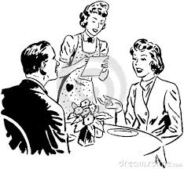

- Fill in the blanks with the correct phrases. ( 10 marks )
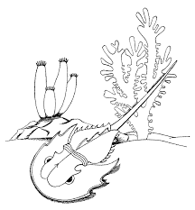
in the sea
oldest living
male crabs

horseshoe crab
five pairs
sea near Johor

The horseshoe crab is among the __________________________ animals on earth. It can be found ________________________________. In Malaysia, it is mostly found in the _______________________________. Its blood is blue. It has _______________________ of gills. The female crabs are bigger than the _________________________.

- Punctuate and write the sentence correctly. ( 15 marks )

Example: we can recycle newspapers to make paper bags greeting card and tissue paper
- the sun heats the earth
- gary gull is flying high in the sky
3. daphney dolphin and whippy whale live in the blue sea
4. pat went to the playground
5. little lazy larry sleeps on the farm
- Read and fill in the blanks based on the text. ( 15 marks )
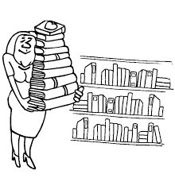
This is Miss Lily. She is 30 years old. She is a librarian. She works in a public library. Every day, she opens the library at 10.00 a.m. She helps the library users to look for books. She also arranges books on the shelves. She closes the library at 5.00 p.m.

Name :______________________________
Age :______________________________
Occupation :______________________________
Place of work :______________________________
Working time :______________________________

