Name : ……………………………………………………………. Year : ……………

SEKOLAH KEBANGSAAN MENJALARA
DUNIA SAINS TEKNOLOGI DLP
( PAPER 1 )

YEAR 2

1 HOUR

DO NOT OPEN THIS PAPER BEFORE EXAM START

Arahan:
1. This paper have 40 question.
2. Answer all question.
3. Answer using OMR paper by shading the exact answer.
4. Each question only need to shade one answer only.
5. If you want to change answer, unshade the answer completely and shade the new answer.

Circle the correct answer.

1. What will happen if we eat less food in below?
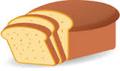
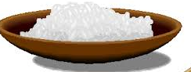

A Growth will be stunned.
B We will have less energyi.
C We will easy to be sick.

2. Bubble map below show 4 human needs.

What is X?

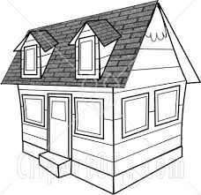
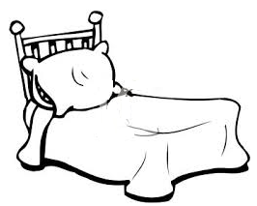
A B C
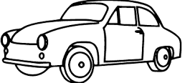

3. When we grow up, we will became more higher and ______________
A more lighter
B more heavier
C more longer

4. Which one is suitable for breakfast?
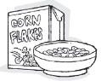
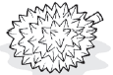

A B C

5. We will not sick if we eat more _________ .
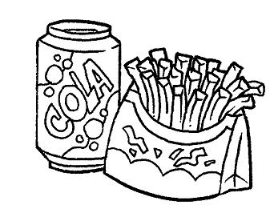
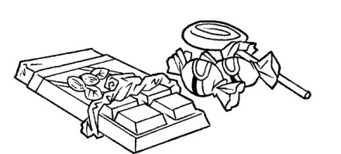
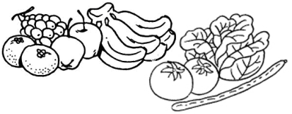
A B C

6. Which one of the answer can protect us from rain and heat?
A Food
B Clothes
C Shelter

7. Maslinda is an athlete. Which one will give her enough energy?
A Rice and bread
B Fish and prawn
C Vegetable and fruit

Importance of food

8.

For energy
For growth

For healthy

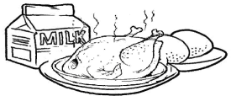
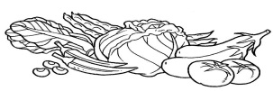

What is ?
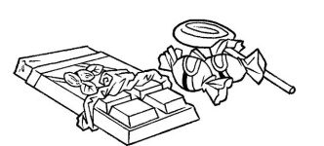
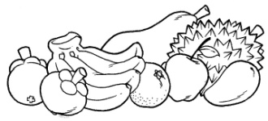
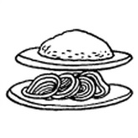
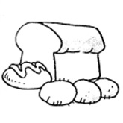
A B C

9. Mei Ling got cold. Mei Ling need to eat________________ to become healthy.
A Chicken and egg
B Vegetable and fruit
C Potato and corn

10. All these food give us energy except
A Cucumber
B Bread
C Rice

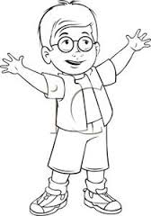
11.

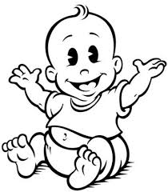

1 tahun 8 tahun
Picture above is Azlee on 1 years old and 8 years old. What changes happen in his growth?
A Azlee became more fairer.
B Azlee’s hair become less.
C Azlee became taller

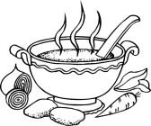
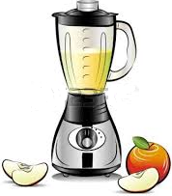
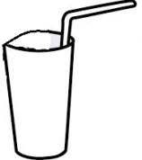
12 .
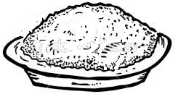

Rice Vegetable soup Apple juice

Issac want to eat lunch. Which one of these food will make the balanced meal.
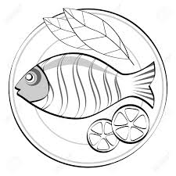
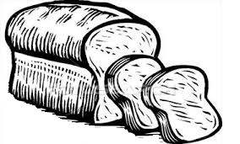

A B C

Bread Fish Cup cake

13. Noah want to make a bowl of cereal. These is the ingredient:

- A cup of cornflake (for energy)
- A glass of fresh milk (for growth)
- ?

What are other ingredient to make a balanced meal?
A A pinch of sugar (for sweet taste)
B A spoon of soy sauce (for salty taste)
C A few piece of strawberry (for keep healthy)

14. Cleanliness is for healthy life. Which one is the clean environment?

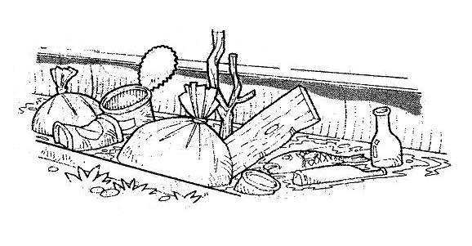
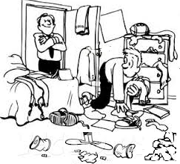
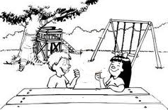
A B C

15. Which of these behavior make the environment dirty?
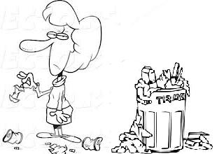
A B C
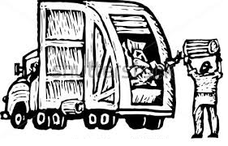
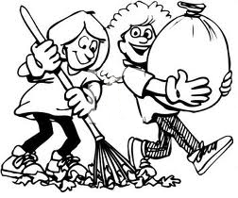

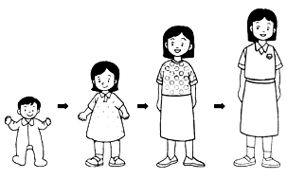
16.

Picture above tell that human ______________ .
A breath B grow C give birth

17. Which of these are the correct way to ensure our food is clean?

A Food need to leave on table to keep it fresh

B Use the fresh and clean ingredient
C Cook in dirty environment.

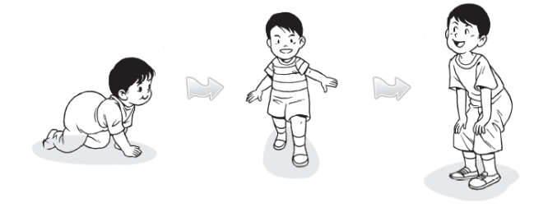
18.

Picture above state that when we grow, we will became more________ .

A the number finger and toes
B longer and slower
C higher and heavier

19. Which of thefollowing can be done in each stage of life?
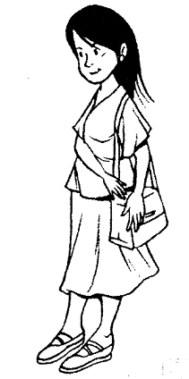
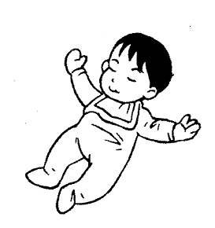
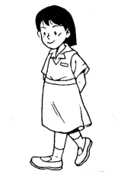

8 month 8 years 28 years

A Crawling Driving a car Sewing
B reading a book Folded clothes Making decission
C laughing Singging Give birth

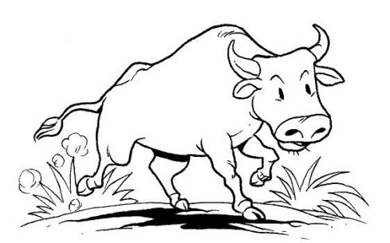
20.

This animal need air to __________ .

A breath B run C grow

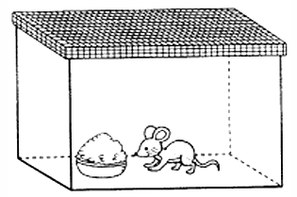
21 .

After a day, the mouse will die because …

A No vegetable in its food
B Water are not provided
C The air is too hot udara

22. A chicken was searching for a worm. What basic need the chicken need?
A Food
B Air
C Water

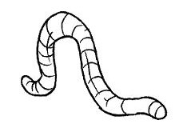

23. You put the worm into a container for experiment. What will you need to provide to keep it living?

A cold air and hot food
B A cup of water and a biscuits
C air hole, wet soil and some leaf

24 . Which animal eat plant only?

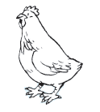
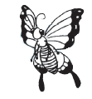
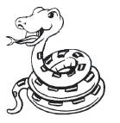
A B C

25. Animals move to ______________________
A Search food and water
B Search a fresh air
C Search for fertile soil

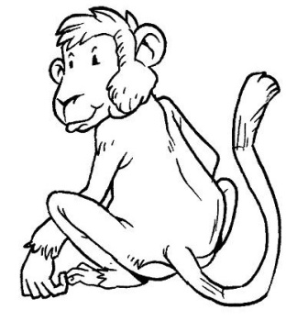
26.

Which are the best food for this animal?
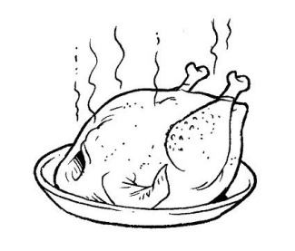
A B C
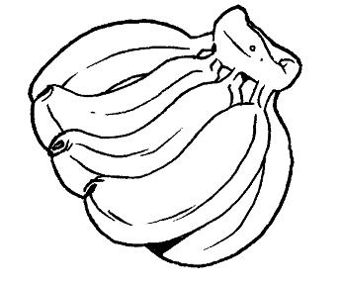
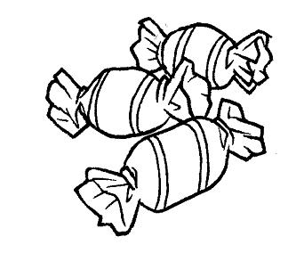

27 Which is the correct animal with it’s shelter?
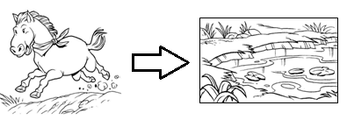
A

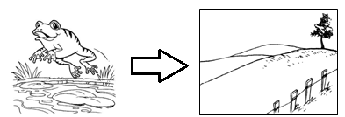
B

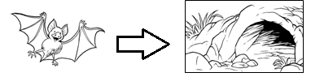
C

28. All of this animal in the same group for what they eat except
A lembu
B kucing
C ayam

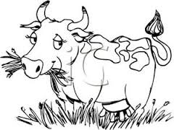
29.

What type of food the animal above eat?
A Animals only
B Plant only.
C Animal and plant.
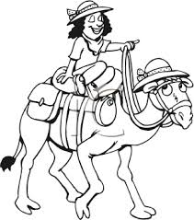
30.

Based on the picture above, what the importance of that animal to human?
A for shelter.
B for transportation.
C for food.

31. Which animal give birth?
A chicken
B whale
C ant

32. Some of the animals doesn’t same appearance with its mother. Which animals in that group?
A baby elephant.
B cow calf .
C tadpoles.

33. each of this animal same as its mother except

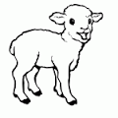
A.
Little lamb

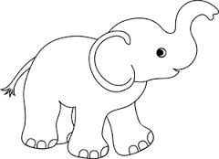
Baby elephant
B

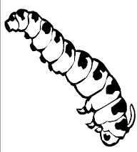
C
Catterpillar

34. Antara berikut, padanan manakah yang betul?
Animal | Its movement
Snake | Shuffle
Crocodile | Crawl
Rabbit | slitther

A
B
C

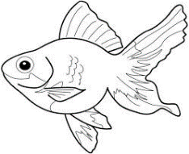
35.

Which animals have same reproduction process with animal above?
A Horse
B Lion
C Frog

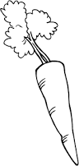
36. Which one of these is the food for snake ?
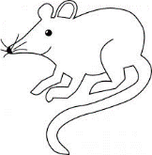
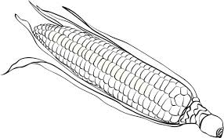
A B C

37. David put an oil on all leaf of a plant. What will happen?
A Plant die because cannot get water.
B Plant die because cannot get shelter.
C Plant die because cannot get air.

38. Plant need awater, air and ________________ for living.
A sunlight
B shelter
C seeds

39.
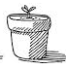
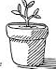
After 10
days

Based on the picture, what changes happen when the plant grow?
A The number of branches and leaves decrease.
B The number of leaf and branches increase.
C The number of leaf and height same.

40. Which of these plant will keep living?
A Plant that watered 2 times a day.
B Plant thatwrapped with plastic.
C Plant that put in a cupboard.

----------------------------------- END OF QUESION -----------------------------------------
Prepared by : Checked by :
-------------------------- -------------------------------
Muhammad Muzhafar Abd Farouk Abd Rahman
(DST Teacher Year 2 SK Menjalara) Ketua Panitia Sains SK Menjalara)
Confirmed by:
_____________________
Hanita bt Yaacob
( PK 1 SK Menjalara)

