NAMA CALON :

NO. KAD PENGENALAN/
NO. SURAT BERANAK :

ANGKA GILIRAN :

PEPERIKSAAN AKHIR TAHUN
TAHUN LIMA 2015
PERINGKAT DAERAH SUBIS
BAHASA MELAYU — PENULISAN 012
Oktober
1¼ jam Satu jam lima belas minit
JANGAN BUKA KERTAS SOALAN INI SEHINGGA DIBERITAHU
1. Tulis nama, nombor kad pengenalan atau
Untuk Kegunaan Pemeriksa
Kod Pemeriksa :
Bahagian | No. Soalan | Markah
A
B
C
JUMLAH |  | 50
nombor Surat beranak dan angka giliran
kamu pada petak yang disediakan.
2. Kertas soalan ini mengandungi tiga bahagian :
Bahagian A, Bahagian B dan Bahagian C.
3. Kamu dikehendaki menjawab ketiga-tiga bahagian.
4. Bagi soalan Bahagian C, kamu boleh memilih sama
ada menjawab soalan 1 atau soalan 2.
5. Jawapan kamu hendaklah ditulis pada ruang
yang disediakan.

Kertas ini mengandungi halaman bercetak

BAHAGIAN A
[ 10 markah ]
( Masa dicadangkan : 15 minit )

Gambar di bawah menunjukkan cara-cara menjaga kebersihan dan kesihatan gigi.
Tulis lima ayat yang lengkap tentang cara-cara menjaga kebersihan dan kesihatan gigi.

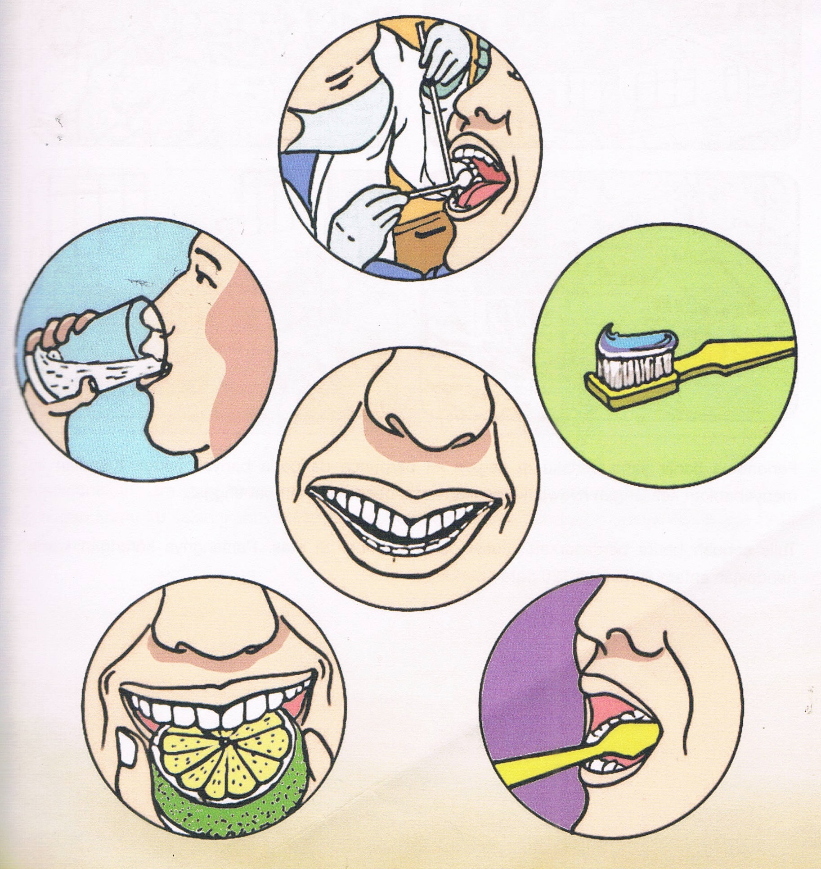

[lihat sebelah
BAHAGIAN A

____________________________________________________________________________________________________________________________________________________________________________________________________________________________________________________________________________________________________________________________________________________________________________________________________________________________________________________________________________________________________________________________________________________________________________________________________________________________________________________________________________________________________________________________________________________________________________________________________________________________________________________________________________________________________________________________________________________________________________________________________________________________________________________________________________________________________________________________________________________________________________________________________________________________________________________________________________________________________________________________________________________________________________________________________________________________________________________________________________________________________________________________________________________________

10

[lihat sebelah

BAHAGIAN B
[ 15 markah ]
( Masa dicadangkan : 25 minit )

Gambar di bawah menunjukkan poster piramid makanan.
Tulis ulasan tentang piramid makanan tersebut dalam bentuk perenggan.
Panjangnya ulasan kamu hendaklah antara 50 hingga 80 patah perkataan.
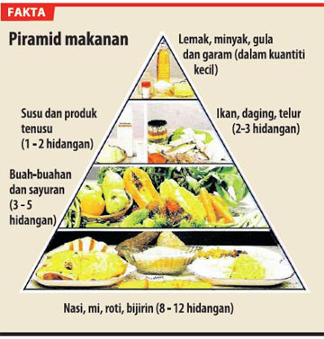

[lihat sebelah

BAHAGIAN B

_________________________________________________________________________________________________________________________________________________________________________________________________________________________________________________________________________________________________________________________________________________________________________________________________________________________________________________________________________________________________________________________________________________________________________________________________________________________________________________________________________________________________________________________________________________________________________________________________________________________________________________________________________________________________________________________________________________________________________________________________________________________________________________________________________________________________________________________________________________________________________________________________________________________________________________________________________________________________________________________________________________________________________________________________________________________________________________________________________________
______________________________________________________________________________________________________________________________________________________
[lihat sebelah

_________________________________________________________________________________________________________________________________________________________________________________________________________________________________________________________________________________________________________________________________________________________________________________________________________________________________________________________________________________________________________________________________________________________________________________________________________________________________________________________________________________________________________________________________________________________________________________________________________________________________________________________________________________________________________________________________________________________________________________________________________________________________________________________________________________________________________________________________________________________________________________________________________________________________________________________________________________________________________________________________________________________________________________________________________________________________________________________________________________
______________________________________________________________________________________________________________________________________________________

15

[lihat sebelah

BAHAGIAN C
[ 25 markah ]
( Masa dicadangkan : 35 minit )

Bahagian ini mengandungi dua soalan. Jawab satu soalan sahaja.
Panjangnya jawapan kamu hendaklah antara 80 hingga 120 patah perkataan.

Soalan 1
Tulis sebuah karangan tentang “Cara-Cara Menghormati Guru”.
Tulis karangan kamu itu selengkapnya.

ATAU

Soalan 2
Satu-satu,
Saya sayang ibu,
Dua-dua,
Saya sayang ayah,
Tiga-tiga,
Sayang adik kakak,
Satu, dua, tiga,
Sayang semuanya.

Rangkap lagu di atas merupakan sebahagian daripada lirik lagu kanak-kanak. Lirik tersebut menggambarkan kasih sayang seorang anak terhadap keluarganya.
Berdasarkan maksud lirik tersebut, ceritakan tentang kasih sayang kamu terhadap keluarga.
Tulis karangan kamu selengkapnya.

[lihat sebelah
BAHAGIAN C
No. Soalan

____________________________________________________________________________________________________________________________________________________________________________________________________________________________________________________________________________________________________________________________________________________________________________________________________________________________________________________________________________________________________________________________________________________________________________________________________________________________________________________________________________________________________________________________________________________________________________________________________________________________________________________________________________________________________________________________________________________________________________________________________________________________________________________________________________________________________________________________________________________________________________________________________________________________________________________________________________________________________________________________________________________________________________________________________________________________________________________________________________________________________________________________________________________________________________________________________________________________________________________________________________________________________________________________________________________________________________________________________________________________________________________________________________________________________________________________________________________________________________________________________________________________________________________________________________________________________________________________________________________________________________________________________________________________________________________________________________________________________________________________________________________________________________________________________________________________________________________________________________________________________________________________________________________________________________________________________________________________________________________________________________________________________________________________________________________________________________________________________________________________________________________________________________________________________________________________________________________________________________________________________________________________________________________________________________________________________________________________________________________________________________________________________________________________________________________________________________________________________________________________________________________________________________________________________________________________________
[lihat sebelah

25
[lihat sebelah

