ENGLISH LANGUAGE – PAPER 2
YEAR 3

SECTION A

Rearrange the words to form correct sentences.
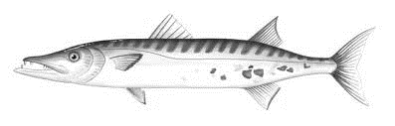

This is
Barracuda..
a
1.

_____________________________________________________________________
(2 marks)

is a fierce
The barracuda
sea creature..
2.

____________________________________________________________________
(2 marks)

It has
teeth.
a sharp
3.

____________________________________________________________________
(2 marks)

It breathes
its gills.
through
4.

____________________________________________________________________
(2 marks)

It has
a long
body.
5.

____________________________________________________________________
(2 marks)
SECTION B

Look at the pictures. Fill in the blanks with the correct phrases.

walks to school | sweeps the floor
reads storybook | watches television
cycles to school | goes for violin lesson
Name | In the morning | In the afternoon | In the evening
Jason | _____________________  _____________________ | does his_______ homework____ | _____________________  _____________________
Fatimah | 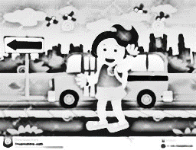  goes to school by bus________ | _____________________  _____________________ | _____________________  _____________________
Kumar | _____________________  _____________________ | _____________________  _____________________ | plays football

12 marks

SECTION C

Look at the pictures. Choose the correct words to name their occupations.
farmer
firefighter
postman
doctor

1.
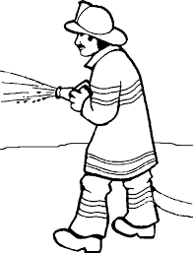

2.

3.
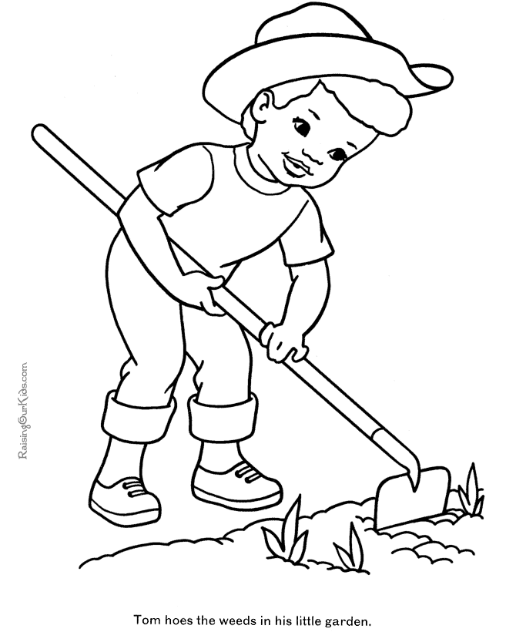

4.

8 marks
SECTION D

Choose the correct verb to complete the sentence.

eats
cleans

walk
sleep

- Tortoises _________________ slowly.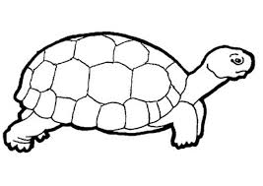
- Daniel’s kittens ___________________ in a basket. 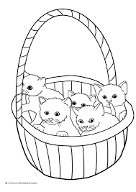
- A rabbit ________________ vegetables.

- Sofia _________________ her goldfish’s aquarium every week. . 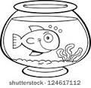

4 marks
Prepared by; Checked and verified by;

Raknawati Rappice Fanny Anthony Johnwyn
(Year 3 English Teacher) (English Head Panel)

SECTION E
Group the words.

durian
mango
cucumber
tomato
pineapple
grape
apple
potato
carrot

onion

Fruit | Vegetable
- _________________________  - _________________________  - _________________________  - _________________________  - _________________________ | - ________________________  - ________________________  - ________________________  - ________________________  - ________________________

10 marks

SECTION F
Write simple sentences to each picture.

Example:
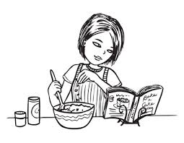
Erin – cooking

I am Erin. I like cooking.

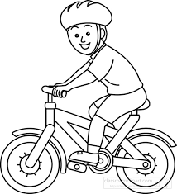
1.
Adam – cycling

_______________________________________________________

(2 marks)

2.
Nurul – drawing

______________________________________________________

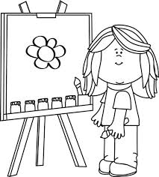

(2 marks)

Izwan – playing computer games

3.

(2 marks)

Prepared by; Checked and verified by;

Ratnawati Rappice Fanny Anthony Johnwyn
(Year 3 English Teacher) (English Head Panel)

