‘A’ and ‘An’ indefinite articles and only used with singular countable nouns.
‘A’ is used before words that begin with consonants sounds or words which begin with the vowel ‘u’ but has a consonant sound (you).
‘An’ is used before words which begin with vowels (a, e, i, o, u) or words which begin with the silent ‘H’.
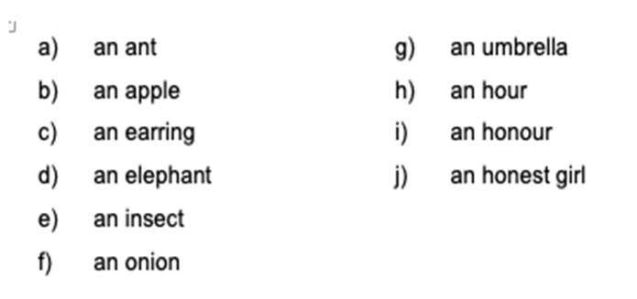
‘a’ and ‘an’ are not use before uncountable nouns. E.g: rice, sand, oil, etc.

‘The’ definite article and is used with plural countable nouns and also
To show something that is special and one of its kinds in the world.
- The sun is setting in the
- The air is fresher in the
To refer to a particular person, animal, thing or place.
- The black cat is under the table.
- That is the car which honked at me yesterday.
For the superlative form of an adjective.
- He is the tallest boy in her class.
- I bought the cheapest book.

With things which are already mentioned before.
A pupil is in a library. The pupil are reading quietly

