|  |
| --- |
| http://cdn.toonvectors.com/images/2/23817/toonvectors-23817-940.jpg  he |
| http://sweetclipart.com/multisite/sweetclipart/files/cute_girl_line_art.png  she |

|  |
| --- |
| http://cdn.toonvectors.com/images/2/23817/toonvectors-23817-940.jpghttp://cdn.toonvectors.com/images/2/23817/toonvectors-23817-940.jpg  http://sweetclipart.com/multisite/sweetclipart/files/cute_girl_line_art.png  we |
| http://sweetclipart.com/multisite/sweetclipart/files/cute_girl_line_art.pnghttp://sweetclipart.com/multisite/sweetclipart/files/cute_girl_line_art.png  http://cdn.toonvectors.com/images/2/23817/toonvectors-23817-940.jpg  they |

Circle the correct personal pronouns.

|  |  |
| --- | --- |
| 1. http://cdn.toonvectors.com/images/2/23817/toonvectors-23817-940.jpg   he she | http://sweetclipart.com/multisite/sweetclipart/files/cute_girl_line_art.png  he she |
| http://cdn.toonvectors.com/images/2/23817/toonvectors-23817-940.jpghttp://cdn.toonvectors.com/images/2/23817/toonvectors-23817-940.jpg  we they | 1. http://sweetclipart.com/multisite/sweetclipart/files/cute_girl_line_art.pnghttp://cdn.toonvectors.com/images/2/23817/toonvectors-23817-940.jpg   http://sweetclipart.com/multisite/sweetclipart/files/cute_girl_line_art.pnghttp://cdn.toonvectors.com/images/2/23817/toonvectors-23817-940.jpg  we they |
| http://sweetclipart.com/multisite/sweetclipart/files/cute_girl_line_art.png  he she | http://cdn.toonvectors.com/images/2/23817/toonvectors-23817-940.jpg6)  he she |
| http://cdn.toonvectors.com/images/2/23817/toonvectors-23817-940.jpghttp://cdn.toonvectors.com/images/2/23817/toonvectors-23817-940.jpghttp://cdn.toonvectors.com/images/2/23817/toonvectors-23817-940.jpghttp://sweetclipart.com/multisite/sweetclipart/files/cute_girl_line_art.pnghttp://cdn.toonvectors.com/images/2/23817/toonvectors-23817-940.jpg7)    we they | http://cdn.toonvectors.com/images/2/23817/toonvectors-23817-940.jpghttp://sweetclipart.com/multisite/sweetclipart/files/cute_girl_line_art.png8)  we they |

Answer sheet.

Circle the correct personal pronouns.

|  |  |
| --- | --- |
| 1. http://cdn.toonvectors.com/images/2/23817/toonvectors-23817-940.jpg   he she | http://sweetclipart.com/multisite/sweetclipart/files/cute_girl_line_art.png  he she |
| http://cdn.toonvectors.com/images/2/23817/toonvectors-23817-940.jpghttp://cdn.toonvectors.com/images/2/23817/toonvectors-23817-940.jpg  we they | 1. http://sweetclipart.com/multisite/sweetclipart/files/cute_girl_line_art.pnghttp://cdn.toonvectors.com/images/2/23817/toonvectors-23817-940.jpg   http://sweetclipart.com/multisite/sweetclipart/files/cute_girl_line_art.pnghttp://cdn.toonvectors.com/images/2/23817/toonvectors-23817-940.jpg  we they |
| http://sweetclipart.com/multisite/sweetclipart/files/cute_girl_line_art.png  he she | http://cdn.toonvectors.com/images/2/23817/toonvectors-23817-940.jpg6)  he she |
| http://cdn.toonvectors.com/images/2/23817/toonvectors-23817-940.jpghttp://cdn.toonvectors.com/images/2/23817/toonvectors-23817-940.jpghttp://cdn.toonvectors.com/images/2/23817/toonvectors-23817-940.jpghttp://sweetclipart.com/multisite/sweetclipart/files/cute_girl_line_art.pnghttp://cdn.toonvectors.com/images/2/23817/toonvectors-23817-940.jpg7)    we they | http://cdn.toonvectors.com/images/2/23817/toonvectors-23817-940.jpghttp://sweetclipart.com/multisite/sweetclipart/files/cute_girl_line_art.png8)  we they |

**Grammar Notes.**

PERSONAL PRONOUNS

We use pronouns to replace the names of people, animals or things.

I

We

You

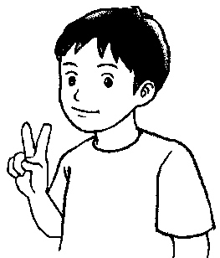

 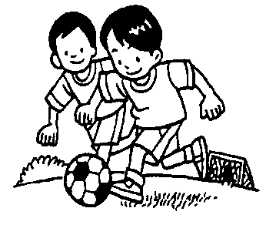

* **I** am Azmi. **You** are Anita. **We** are boys.
* **I** am nine years old. **You** are a pretty girl. **We** have same hobby.
* **I** am a good boy. **You** are a good girl. **We** are good friends.

It

She

He

They

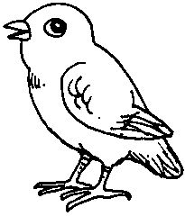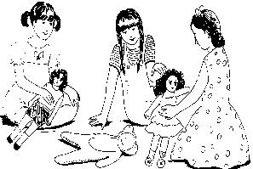 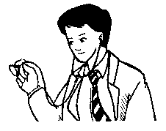 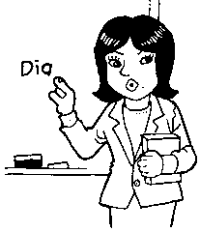

**They** are girls. That is Mr. John. That is Miss Juli. This is a bird.

**They** play dolls. **He** is a doctor. **She** is a teacher. **It** has wings.

**They** are sisters. **He** works in a clinic. **She** teaches English. **It** has a beak.

Name : _________________________ Class : _________________

1. Choose the correct personal pronouns for each pictures shown.

he she it they we

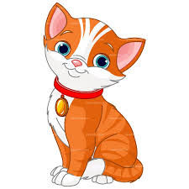

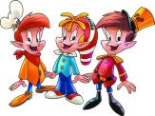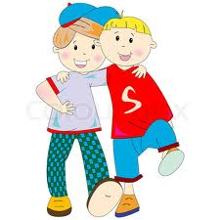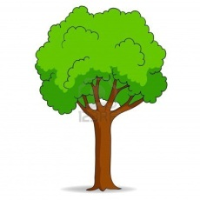

https://encrypted-tbn1.gstatic.com/images?q=tbn:ANd9GcQ3bnTAtP6QNZZYFOWHlok2-DHhm6PG7zFD031GKXZCFJvzJuuZrOIIV_U

1. Change the underlined phrases into the correct personal pronouns.
2. Suzy and Tina are good dancers. -> __________________________
3. Pak Mat is my closest neighbour. -> __________________________
4. Hasif and I are best friends. -> __________________________
5. My sister is twelve years old. -> __________________________
6. Mr. Maniam is a strict headmaster. -> __________________________
7. The bicycle is new and red. -> __________________________
8. The table is rectangle. -> __________________________
9. My brother and I go to school together. -> ________________________