Grammar Nouns

A noun is used to refer to a person, place, animal or thing.
- Student (person)
- Park (place)
- Cat (animal)
- Cycle (thing)

Nouns can be countable or uncountable.

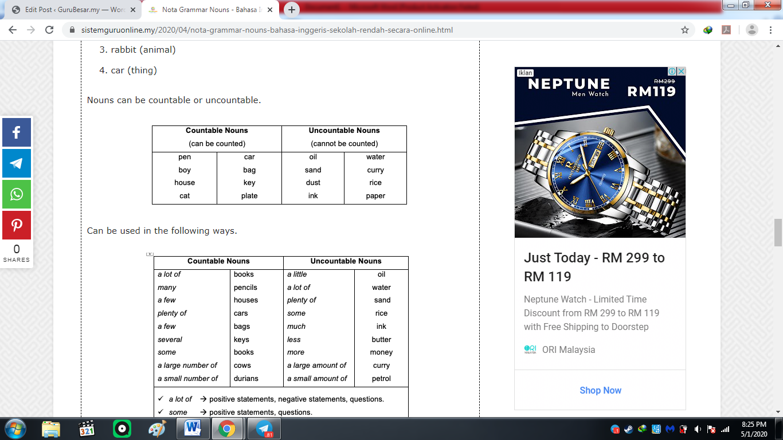

Can be used in the following ways.
