EVIDENCES
B6 DL1 E1:
Able to respond and demonstrate understanding of short stories by talking about
(i) the characters
(ii) the events

B6 DL2 E1:
Able to recite rhymes in groups and individually with correct stress, rhythm and intonation.

B6 DB3E1:
Able to choose and record the number of texts read.

B6 DT4 E1:
Able to create :
a. greeting cards
b. lists

B6DL1E1
Listening and speaking
Activities:
- Teacher displays the story on LCD.
(if the LCD is not provided, teacher can refer to the text book).
- Teacher reads aloud the story and pupils listen. (incorporate some suitable movement and vary the intonation to enhance pupils’ absorption of information, the usage of props to assist the process of teaching is very much suggested).
- Teacher reads aloud the story once again line by line and ask the pupils to follow after him/her in order to correct pupils’ pronunciation.
- The pupils read aloud together one more time. (This time with less guidance from the teacher.)
- Teacher asks some simple yes/no replies and wh- question towards the pupils in order to assess pupils’ comprehension of the short story. (emphasize more on the characters and the events occur in the story.)
- Sample of questions and the checklist are provided.
- Accept any possible answer.

B6DL1E1
The sample of the short story

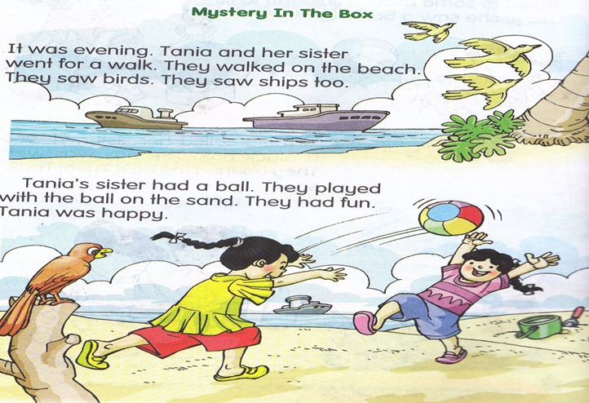
B6DL1E1
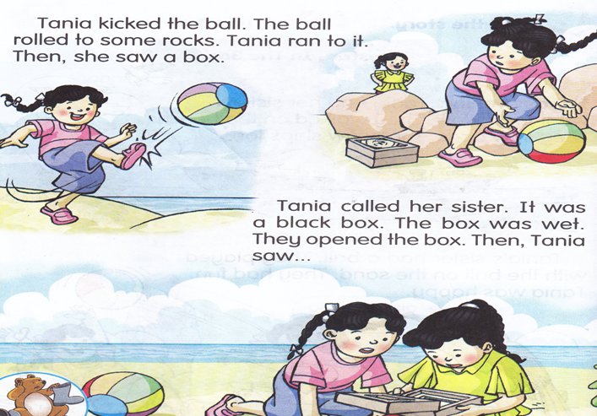

B6DL1E1
Listening and Speaking.

Sample of wh-questions to be asked by the teacher.
- Who are the people in the story?
_________________________
- What did they see at the beach?
_________________________
- Where did they play the ball?
_______________________
- What did Tania sees at the rock?
__________________________
- What do you think is in the box?
_________________________

Sample of yes/no replies questions to be asked by the teacher.

- Did Tania and her sister go for a walk in the evening?
___________________________________
- Did the ball roll to some rocks?
_____________________
- Is the colour of the box red?
________________________

B6DL1E1
The checklist.
NAME :_____________________
CLASS :_____________________
DATE :_____________________
Wh-questions | Tick (√) if Pupils are able to answer.
- Who are the people in the story?

- What did they see at the beach?

- Where did they play the ball?

- What did Tania sees at the rock?

- What do you think is in the box?

Yes/no replies questions | Tick (√) if Pupils are able to answer.
- Did Tania and her sister go for a walk in the evening?

- Did the ball roll to some rocks?

- Is the colour of the box red?

Nama pentaksir:___________________

B6DL2E1
Listening and speaking
Activities:
- Teacher shows the flash cards to the pupils.
- Teacher stresses words with initial, medial and final sounds, eg:, head, shoulders, knees, toes, eyes, ears, mouth and nose.
- Teacher reads the rhymes line by line. Pupils listen and repeat.
- Teacher plays a video of the song to the pupils. (the lyrics of the song is provided in the video)
- Pupils watch the video.
- Teacher plays the video one more time.
- Teacher sings along with the song and recites the rhyme with correct stress, rhythm and intonation.
- Pupils recite the rhyme together with the teacher.
- Pupils recite the rhyme in groups, pairs and individually with correct stress, rhythm and intonation.

B6DL2E1

The sample of the video.

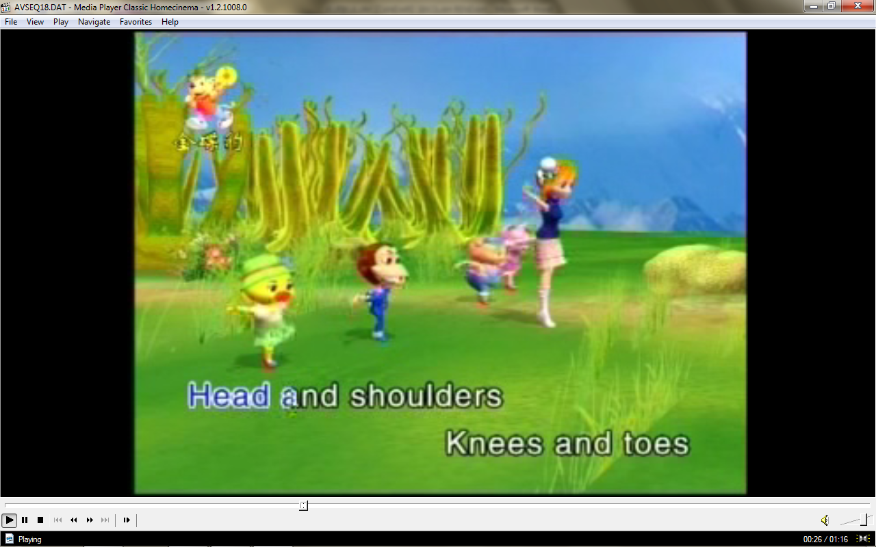

B6DL2E1
The sample of the flash cards.
,
head

shoulders

knees

toes

B6DL2E1
eyes

ears

mouth

nose

B6DL2E1
The lyrics.

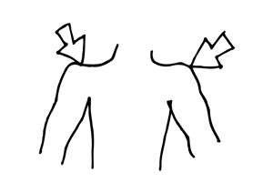
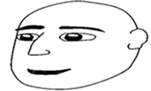

Head and shoulders.

Head and shoulders,
Knees and toes,
Knees and toes,
knees and toes.
Head and shoulders,
Knees and toes,
Eyes, ears,
Mouth and nose.


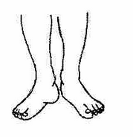
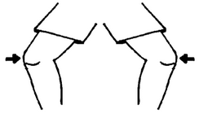

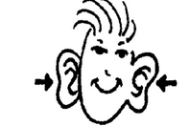

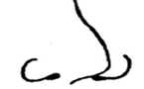

B6DL2E1
The checklist.

NAME :________________________
CLASS :________________________
DATE :________________________
The sound system | Able | Unable
head

Shoulders

Knees

Toes

Eyes

Ears

Mouth

Nose

Nama pentaksir:____________________
Reading.

Activities.
- Teacher distributes reflective sheet to the pupils and ask them to paste the sheet at the back of their exercise book. (so that, the pupils won’t lost the sheet).
- During the library/ free reading session, teacher picks pupils randomly and asked them to choose one of the story book and read aloud the story to the teacher.
- Teacher assists the pupils by providing guidance if they are having difficulties in reading. (Do not disrupt the pupils’ flow in reading, if pupils make mistake in their reading, correct them after they finish reading the story).
- After they are done reading, ask them to fill in the reading log with the information needed.
- The sample of the reading log is provided at the next slide.

B6DB3E1
Sample of the books (fiction)
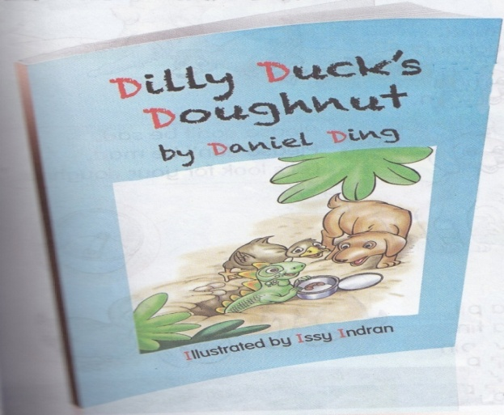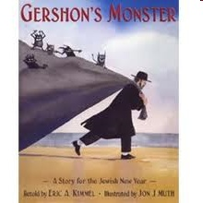

Sample of the books (non-fiction)
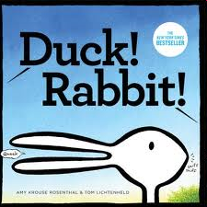
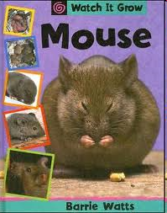

B6DB3E1
NAME :__________________
CLASS :__________________
DATE :__________________

Reading log
No | Genre | Title.

Nama pentaksir:____________________

Writing.
Activities:
- Teacher shows a few sample of greeting cards.
- Teacher explains the purpose of the cards. (which is to wish other person’s well being or show appreciation in specific occasions).
e.g A birthday card is given to people who celebrate their birthday.
3. Teacher points out the message printed on the cards.
(teacher explains that the message in the card must be
written with positive thoughts and wish for only good
things.)
- Teacher asks what other cards can be created.
- Teacher divides pupils into several groups.
- In their respective groups, teacher asks the pupils to list all the occasions or special days that people celebrate. (teacher can provide the list sheet or ask pupils to produce it)
- Teacher asks pupils to create a greeting card according to the special days the pupils have listed.
e.g group 1- create a father’s day card.
group 2- create a mother’s day card.
group 3- create a teacher’s day card.

B6DT4E1
NAME:
CLASS:
DATE:
List down the special events and the festivities that you know.
No | The special events/festivities
e.g 1 | e.g Teacher’s Day

Nama pentaksir:____________________

B6DT4E1

Sample of a greeting card taken from the workbook.
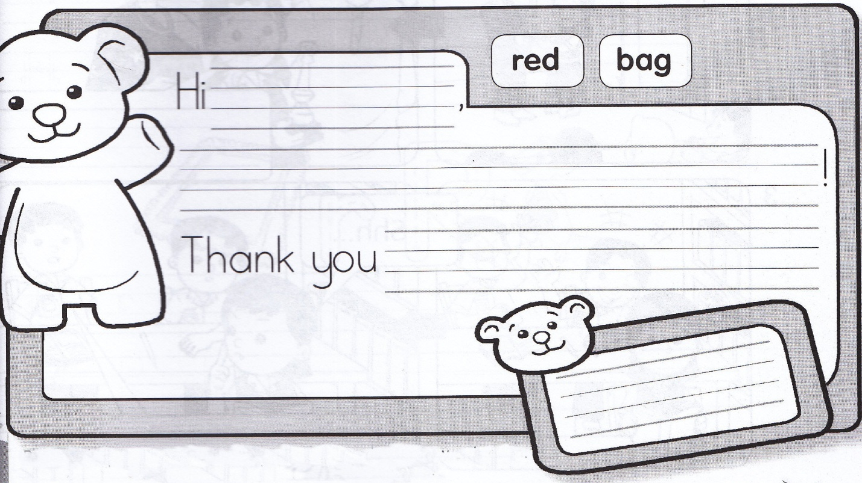

B6DT4E1

Sample of the greeting cards from the internet.

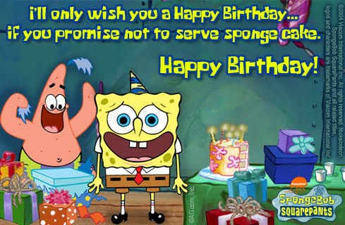

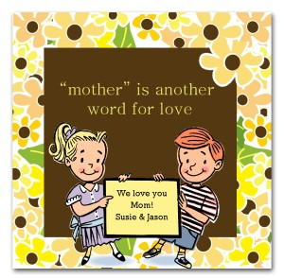

B6DT4E1
NAME :_______________________
CLASS :_______________________
DATE :________________________
Create a greeting card and paste it in the box given.

Nama pentaksir:___________________

