B1DL1E1
Name:_________________ Date:___________________
Class:__________________
Listen and sing.

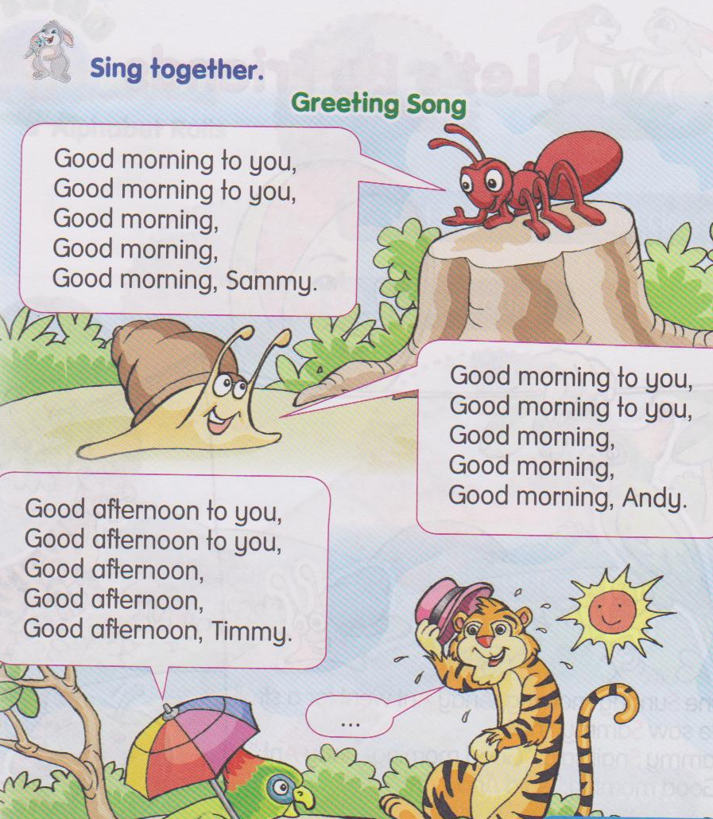

(tune: Birthday song)
The pupils are able to : | Tick (/) if pupils are able to perform
Repeat rhymes after the teacher
Sing along with the teacher
Sing in groups

Nama pentaksir:____________________

Name :_________________ Date :_________________
B1 DB2 E1
Class :__________________
Match.
B
T
M
S
N
m
s
n
b
t
1

2

3

4

5

Nama Pentaksir :_______________________
B1DB3E1
Name:_____________________ Date:___________________
Class:_____________________
Say the missing letters.

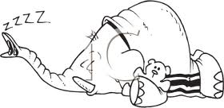


tap nap bin
_ap _ap _in
t_p n_p b_n
ta_ na_ bi_


cat man
_at _an
c_t m_n
ca_ ma_

Nama pentaksir:________________________

B1DB5E1
Name :____________________
Class :____________________
Date :____________________
Read and spell correctly.
t a p n a p b i n

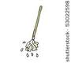
m o p m a p s u n


m a n c a t p o t

Nama pentaksir :_________________

B1DB4E1
Name :____________________
Class :____________________
Date :____________________
Read aloud the words given.
  d | og
c | at
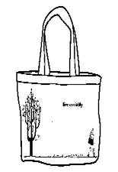  b | ag
  j | ug
  m | ug
  p | an
  t | in

Nama pentaksir :_________________

B1DT6E1
Name :________________________
Class :________________________
Date :________________________
Trace it.
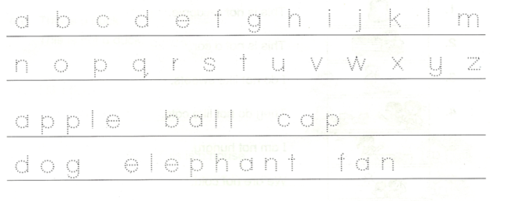
Follow the arrow and draw the pattern.
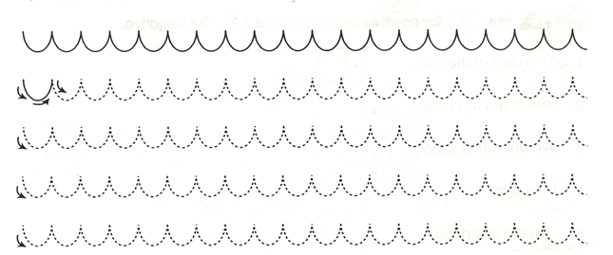
Nama pentaksir :_________________

