SULIT

UJIAN DIAGNOSTIK
UJIAN PENCAPAIAN SEKOLAH RENDAH, 2016

DAERAH JULAU

BAHASA INGGERIS – PEMAHAMAN

BAHAGIAN A 013

1 hour 15 minutes Satu jam lima belas minit

________________________________________________________________________________________

JANGAN BUKA KERTAS SOALAN INI SEHINGGA DIBERITAHU

1. Kertas soalan ini mengandungi dua bahagian : Bahagian A dan Bahagian B.

2. Kamu dikehendaki menjawab semua soalan dalam kedua-dua bahagian ini.

3. Tiap-tiap soalan dalam Bahagian A diikuti oleh empat pilihan jawapan iaitu
A, B, C dan D. Bagi setiap soalan, pilih satu jawapan sahaja. Hitamkan jawapan kamu
pada kertas jawapan objektif yang disediakan. Jika kamu hendak menukar jawapan,
padamkan tanda yang telah dibuat. Kemudian hitamkan jawapan yang baharu.

4. Ceraikan Bahagian B daripada kertas soalan ini.

__________________________________________________________________________________
Kertas soalan ini mengandungi 5 halaman bercetak di Bahagian A
dan 7 halaman bercetak di Bahagian B.

013 1
SULIT

SULIT 013
Section A
[20 marks]

Choose the best answer to complete the sentence.
Pilih jawapan yang terbaik untuk melengkapkan ayat berikut.

1 Kumari is wearing the watch she got for her birthday _______________ her wrist now.
A on
B into
C under
D above

2 John and Jim had to ___________ across the river to pluck the ripe rambutans.
A swim
B swam
C swims
D swimming

3 The little girl could not buy her favourite ice cream as she did not have _________
money.
A any
B little
C many
D some

4 Sameera is _______________ than her stepsister.
A pretty
B prettier
C prettiest
D more prettiest

5 Campaigns to save rivers are held regularly. _______________, people continue to
dispose rubbish in them.
A Since
B Unless
C However
D Although

Choose the most suitable proverb.
Pilih peribahasa yang paling sesuai.

6 After spending a week camping in the cold, damp forest, Rena feels good to be back
home. As the saying goes, __________________________.
A no man is an island
B there’s no place like home
C familiarity breeds contempt
D absence makes the heart grow fonder

013 2 SULIT
SULIT 013

Choose the best answer for each blank.
Pilih jawapan terbaik untuk setiap tempat kosong.

Liz _______7__________ her mother to the market. They buy lots of fresh vegetables, several

types of fish and _________8__________ meat. Then on _______9________ way home, they

stop at a florist to buy a bouquet of daisies for Liz’s grandmother who is down with the flu.

7 A follow
B follows
C followed
D following

8 A some
B many
C much
D a few

9 A their
B your
C our
D her

Choose the word that has the similar meaning as the underlined word.
Pilih perkataan yang sama erti dengan perkataan yang bergaris.

10 Students entering the school library must be quiet and refrain from talking.

A loud
B noisy
C silent
D graceful

Choose the sentence with the correct punctuation.
Pilih ayat yang mempunyai tanda baca yang betul.

11 A This laptop isn’t Peters. It’s Sharons’.
B This laptop isn’t peter’s. It’s Sharon’s.
C This laptop isn’t Peter’s. It’s Sharon’s.
D This laptop isn’t Peter. It’s Sharons.

013 3 SULIT

SULIT 013

Look at the picture and choose the best answer.
Lihat gambar dan pilih jawapan yang terbaik.
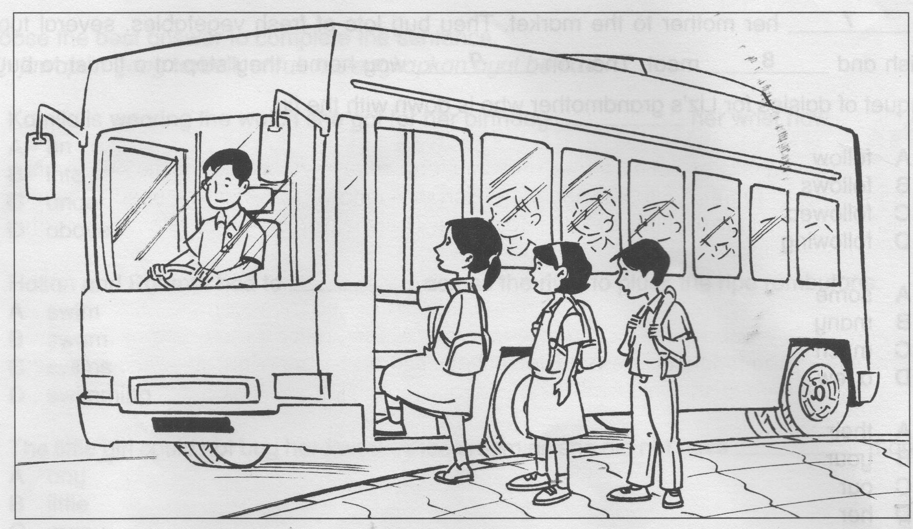

Misha wants to go to town to buy a few storybooks. She waits for the bus at the ____12____

near her house. After waiting for ____13____ hour, the bus arrives. She gets _____14_____

the bus and pays the fare to the driver. There are many _____15_____ seats as there are very

few passengers. Misha quietly reads a book during the journey.

12 A jetty
B airport
C bus stop
D taxi station

13 A -
B a
C an
D the

14 A inside
B onto
C in
D at

15 A old
B full
C vacant
D occupied

013 4 SULIT
SULIT 013

Questions 16 to 20
Read the passage below carefully and answer the questions that follow.
Baca petikan di bawah dan jawab soalan-soalan yang berikutnya.

The National Planetarium is a blue-domed structure which is situated on top of a hill in the Lake Gardens, Kuala Lumpur. It is managed by the Malaysian National Space Agency (ANGKASA).
Its main hall exhibits items and matters related to space science. Among them is the Arianne IV space engine, which was one of the engines used to launch MEASAT 1, Malaysia’s first satellite into space. There is also a 14-inch telescope located in the observatory.
One of the major attractions of this planetarium is the space theatre which screens space-related shows and large format films. The management also organizes programmes on space education to create awareness among members of the public. Sometimes, competitions are held for schoolchildren to bring out their creativity and encourage them to show interest in acquiring scientific knowledge.

16 Where is the National Planetarium situated?
A In space
B On a hill
C Below a hill
D On a blue dome

17 Who can visit the planetarium?
A Everyone
B Astronauts
C Schoolchildren
D Working adults

18 Why does the management of the planetarium organise space education
programmes from time to time?
A To help launch MEASAT 1
B To encourage people travel to space
C To encourage the creativity of schoolchildren
D To create public awareness on the importance of space education

19 What is the name of Malaysia’s first satellite in space?
A Arianne IV
B MEASAT 1
C Blue Dome 1
D Space Engine IV

20 The word acquiring in the passage can be best replaced with ________________.
A buying
B gaining
C forgoing
D surrendering
013 5 SULIT
SULIT

NO KAD PENGENALAN/
NO. SIJIL KELAHIRAN

ANGKA GILIRAN

UJIAN DIAGNOSTIK
UJIAN PENCAPAIAN SEKOLAH RENDAH, 2016
DAERAH JULAU

BAHASA INGGERIS – PEMAHAMAN 013
Bahagian B
________________________________________________________________________________________
Untuk Kegunaan Pemeriksa
JANGAN BUKA KERTAS SOALAN INI SEHINGGA
Kod Pemeriksa :
DI BERITAHU
Markah
No. Soalan
1. Tulis nombor kad pengenalan atau nombor sijil

21
(a)
kelahiran dan angka giliran kamu pada petak-
(b)
petak yang disediakan.
(c)

2. Jawapan kamu hendaklah ditulis pada ruang
(a)

22
yang disediakan dalam kertas soalan.
(b)

3. Serahkan Bahagian B ini bersama-sama borang
(c)
jawapan objektif kepada pengawas
(d)
peperiksaan pada akhir peperiksaan
(e)

23
(a)
(b)

(c)
(d)
(e)

24
(a)
(b)

25
(a)

(b)
(c)
Jumlah
30
30

________________________________________________________________________________________
Kertas soalan ini mengandungi 7 halaman bercetak.

013 6 SULIT

SULIT 013

Section B
[30 marks]
Question 21
Based on the given pictures, give the correct answers in full sentences.
Write your answers in the spaces provided.
Berdasrkan gambar-gambar, berikan jawapan dalam ayat yang penuh.
Tulis jawapan di tempat yang disediakan.
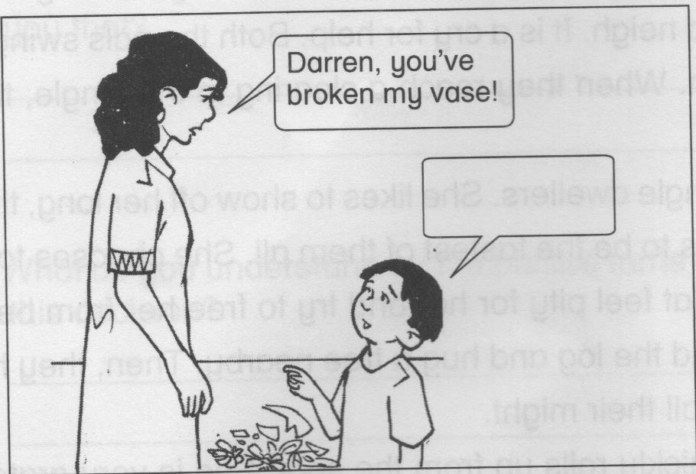
(a)
Answer :

_____________________________________

_____________________________________

_____________________________________
[2 marks]

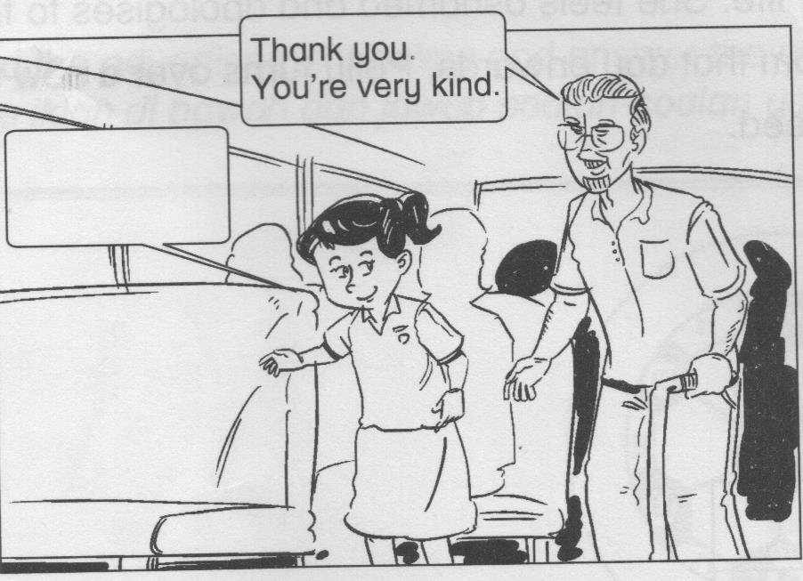
(b) Answer :

_____________________________________

_____________________________________

_____________________________________
[2 marks]

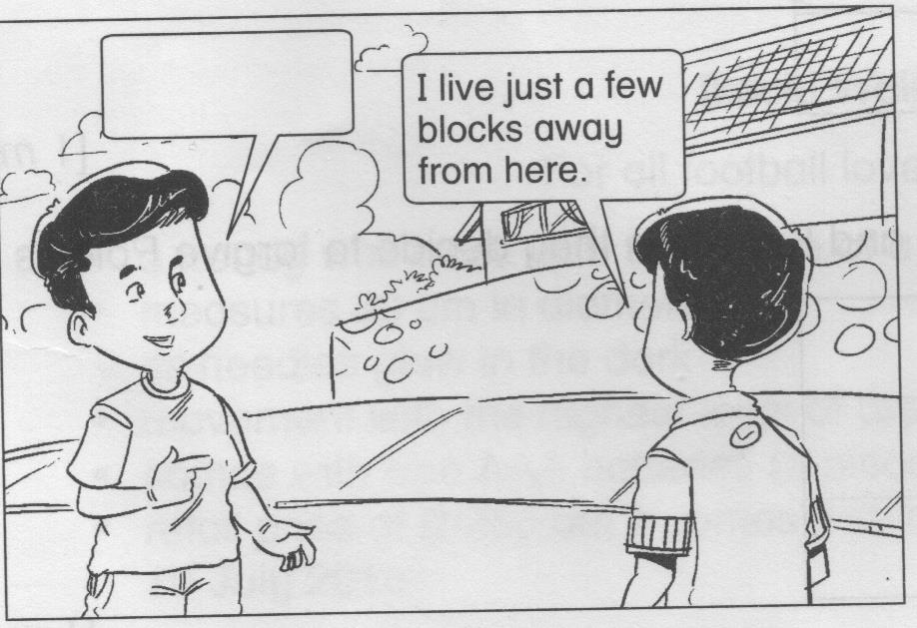
(c)
Answer :

_____________________________________

_____________________________________

_____________________________________
[2 marks]

013 7 SULIT
SULIT 013

Read the story below and answer the questions that follow.
Baca cerita di bawah dan jawab soalan-soalan berikutnya.

Kit and Kat are good friends. They live in the jungle and their favourite pastime is to swing from tree to tree. Kit likes to eat bananas while Kat loves wild berries. Kit has brown fur, while Kat’s is gray. Both have small ears and a long tail each. Kit is very friendly and has many friends. However, Kat is a little shy and timid.
Kit comes from a large family with nine siblings while Kat has two sisters. One day while playing hide-and-seek, Kit and Kat hear a loud neigh. It is a cry for help. Both the pals swing as fast as lightning to reach the victim. When they reach a clearing in the jungle, they find Polly crushed beneath a huge log!
Now, Polly is the most boastful of all the jungle dwellers. She likes to show off her long, thick and shiny tail and strong legs. She also claims to be the fastest of them all. She chooses to be friends with her clan only. However, Kit and Kat feel pity for her and try to free her from being crushed further. They roll their long tails around the log and hug a tree nearby. Then, they huff and puff as they pull the huge log with all their might.
Finally, the log is lifted a little and Polly quickly rolls up from the spot. She is very grateful to Kit and Kat and thanks them for saving her life. She feels ashamed and apologises to them for her naughty behavior all these years. From that day onwards, Polly turns over a new leaf. Kit and Kat are happy to have done a good deed.

Question 22
Tick (√) the correct answer.
Tanda (√) bagi jawapan yang betul.

(a) Kit and Kat are fond of ……………..

swinging from one tree to another tree.

eating wild berries.

making friends.

[1 mark]

(b) The most suitable proverb to describe Kit and Kat when they decide to forgive Polly
is …………….

blood is thicker than water

let bygones be bygones

once bitten, twice shy

[1 mark]

013 8 SULIT

SULIT 013

Write your answers in the spaces provided.
Tulis jawapan anda dalam ruangan yang diberi.

(c) What animal can Polly actually be? Why do you say so?

__________________________________________________________________________________

__________________________________________________________________________________
[2 marks]

(d) Was it easy for Kit and Kat to lift the log off Polly’s body? Which line in the passage
tells you that?

___________________________________________________________________________________

___________________________________________________________________________________
[2 marks]

(e) What do you understand by the phrase turn over a new leaf? Why do you think Polly
made this decision?

___________________________________________________________________________________

__________________________________________________________________________________
[2 marks]

Read the advertisement below and answer the questions that follow.
Baca iklan di bawah dan jawab soalan-soalan yang berikutnya.

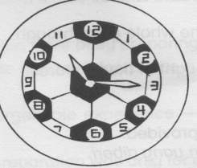

Seiko Wall Clock
For all football lovers out there ……

● a trendy wall clock
● measures 30 cm in diameter
● its needles glow in the dark
● movement with the highest level of precision and a quiet tick
● comes with free AAA batteries (3 pieces)
● retail price of RM50 but it comes with a 30% discount if you buy before 10 July 2016

Hurry to your nearest Seiko Store to grab this item while stock lasts!

013 9 SULIT
SULIT 013

Question 23
Tick (√) the correct answer.
Tandakan (√) bagi jawapan yang betul.

(a) If Syed buys this clock, he would most probably place it on the ………

study table.
floor.
wall.
[1 mark]

(b) John buys the Seiko wall clock on 1 July 2016. He will receive …….

a 30% discount.
free batteries.
a free gift
[1 mark]

(c) Write TRUE or FALSE for each sentence below.
(i) The needles on the clock can light up the dark room. ____________________

(ii) The actual price of the clock is RM50. ____________________

(iii) The 30% discount is for the whole year through. ____________________

(iv) This clock can only be bought at Seiko Store. ____________________
[2 marks]

Write your answers in the space provided.
Tulis jawapan anda dalam ruangan yang diberi.

(d) What is the Seiko Store promoting in the advertisement?

____________________________________________________________________________________

____________________________________________________________________________________
[2 marks]

(e) What is the function of the needles that glow in the dark?

_____________________________________________________________________________________

_____________________________________________________________________________________
[2 marks]

013 10 SULIT
SULIT 013

Study the flyer and read the dialogue below. Answer the questions that follow.
Teliti risalah dan baca dialog di bawah. Jawab soalan-soalan berikutnya.
Branded items going at ridiculous prices!

WAREHOUSE CLEARANCE SALE
7 10 October 2016

Sports attire 30% - 50%
Bags, purses and wallets 50% - 80%
Shoes and belts 50%
Perfumes and cosmetics 30% - 40%

Hurry and grab this golden opportunity. All items MUST go!!

Address : INTEGRATE Suppliers Bhd.
6, Jalan Belanga,
Taman Mas,
58100 Kuala Lumpur

We are open from 10 a.m. to 11 p.m. daily during the sale. The first 50 customers each day will receive a cash voucher worth RM20 upon entering the premise.

50%
80%

Ramli : Hi, Raman. How do you do?
Raman : Hey Ramli. How do you do? It’s nice to hear from you. It’s been some time since
we last spoke.
Ramli : Oh yes, I’m sure that you too were busy preparing for the recent examination
that all the Year 6 pupils nationwide had to sit for. It was a really nice hectic time
for us. Don’t you think so?
Raman : Yes, it was surely an unforgettable experience – all the tuitions and extra classes
that we had to attend!
Ramli : Hmmm…..anyway, all the preparation was only for our own good, to prepare us
for the challenges of the real world. Okay, actually I called to ask if you would
like to go to a warehouse sale in town this weekend. My father is taking me
there. Many branded items are going dirt cheap and I don’t want to miss this
opportunity.
Raman : Wow, that’s fantastic! I could pick something for my dear mum whose birthday is
just around the corner.
Ramli : Great! We will come and fetch you at around 8.30 on Saturday morning. Let’s try
to be there early as they are giving out cash vouchers to 50 early customers
day.
Raman : Alright. I’ll be ready and waiting for you. Thanks for the invitation. Bye.
Ramli : See you on Saturday. Bye.

013 11 SULIT
SULIT
Questions 24 and 25
Tick (√) the correct answer.
Tandakan (√) bagi jawapan yang betul.

24 (a) What is the duration of the Warehouse Clearance Sale?

Seven days
Three days
Four days
[1 mark]

(b) Which of these items is probably not on sale?

A Holex waterproof watch
A Donia leather handbag
A pair of jersey and shorts
[1 mark]

“ Many branded items are going dirt cheap and I don’t want to miss this opportunity.”
25 (a)

Why do you think Ramli said this?

________________________________________________________________________________

________________________________________________________________________________
[2 marks]

(b) Why do you think the warehouse management is giving out cash vouchers to early
customers during the sale?

________________________________________________________________________________

________________________________________________________________________________
[2 marks]

(c) Raman wants to buy a birthday gift for his mother. Suggest an item that Raman
can buy and give a reason to support your suggestion.

________________________________________________________________________________

________________________________________________________________________________
[2 marks]
KERTAS SOALAN TAMAT
013 12 SULIT

ITEM SPECIFICATIONS
COMPREHENSION PAPER ( PART A )
DIAGNOSTIC TEST, 2016 ( JANUARY )

QUESTIONS | CATEGORY | LEVEL
Q1 | PREPOSITIONS | LOW
Q2 | VERB | LOW
Q3 | QUANTIFIERS | MEDIUM
Q4 | COMPARISON OF ADJECTIVES | MEDIUM
Q5 | CONJUNCTIONS | MEDIUM
Q6 | PROVERB | HIGH
Q7 | VERBS | LOW
Q8 | QUANTIFIERS | MEDIUM
Q9 | POSSESSIVE PRONOUNS | MEDIUM
Q10 | SYNONYMN | MEDIUM
Q11 | PUNCTUATIONS | MEDIUM
Q12 | PLACE | LOW
Q13 | ARTICLES | LOW
Q14 | PREPOSITIONS | MEDIUM
Q15 | ADJECTIVE | MEDIUM
Q16 | READING COMPREHENSION | LOW
Q17 | READING COMPREHENSION | LOW
Q18 | READING COMPREHENSION | MEDIUM
Q19 | READING COMPREHENSION | MEDIUM
Q20 | READING COMPREHENSION | HIGH

ANSWERS
COMPREHENSION PAPER ( PART A ) - MCQ
DIAGNOSTIC TEST, 2016 ( JANUARY )

QUESTION NO. | ANSWERS | QUESTION NO. | ANSWERS
1 | A | 11 | C
2 | A | 12 | C
3 | A | 13 | C
4 | B | 14 | B
5 | C | 15 | C
6 | B | 16 | B
7 | B | 17 | A
8 | A | 18 | D
9 | A | 19 | B
10 | C | 20 | B

ITEM SPECIFICATION
COMPREHENSION PAPER ( PART B ) – SUBJECTIVE
DIAGNOSTIC TEST, 2016 ( JANUARY )

QUESTION NO. |  | CATEGORY | LEVEL
21 | a | TO APOLOGISE | LOW
 | b | TO BE THANKFUL | LOW
 | c | TO ASK | MEDIUM
22 | a | READING COMPREHENSION | MEDIUM
 | b | READING COMPREHENSION | HIGH
 | c | READING COMPREHENSION | MEDIUM
 | d | READING COMPREHENSION | HIGH
 | e | READING COMPREHENSION | HIGH
23 | a | READING COMPREHENSION | MEDIUM
 | b | READING COMPREHENSION | MEDIUM
 | c | READING COMPREHENSION | MEDIUM
 | d | READING COMPREHENSION | HIGH
 | e | READING COMPREHENSION | HIGH
24 | a | READING COMPREHENSION | LOW
 | b | READING COMPREHENSION | MEDIUM
25 | a | READING COMPREHENSION | HIGH
 | b | READING COMPREHENSION | HIGH
 | c | READING COMPREHENSION | HIGH

SUGGESTED ANSWERS
COMPREHENSION PAPER ( PART B ) – SUBJECTIVE
DIAGNOSTIC TEST, 2016 ( JANUARY )

21. Accept any logical and meaningful response.
(a) I’m sorry, Mum.
(b) You are welcome.
(c) Where do you live?

22. (a) swinging from one tree to another tree
(b) let bygones be bygones
(c) Polly is most probably a horse, as horses neigh
(d) No…..”they huff and puff as they pull the huge log with all their might”
(e) The meaning of the phrase “turns over a new leaf” refers to changing one’s
attitude or behavior for the better. Polly makes this decision because she is
ashamed of herself as she was very proud and naughty before that accident.

23. (a) wall
(b) a 30% discount
(c) (i) False
(ii) True
(iii) False
(iv) True
(d) Seiko Store is promoting a trendy wall clock.
(e) The needles that glow in the dark help one to read the time even in the dark.

24. (a) Four days
(b) A Holex waterproof watch

25. (a) Ramli probably does not want to miss the sale as most things are sold at very low
prices/cheap.
(b) Accept any suitable answer.
Suggested answer.
The management wants to attract as many customers as possible. / The
management encourages customers to go to the warehouse early to avoid the
rush in the evening.
(c) Accept any suitable answer.

